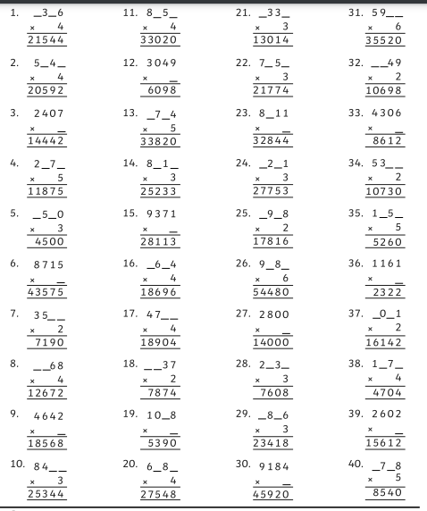

Extension problems - Thursday Maths 4 by 1 digit multiplication