WALT use column multiplication to solve word problems
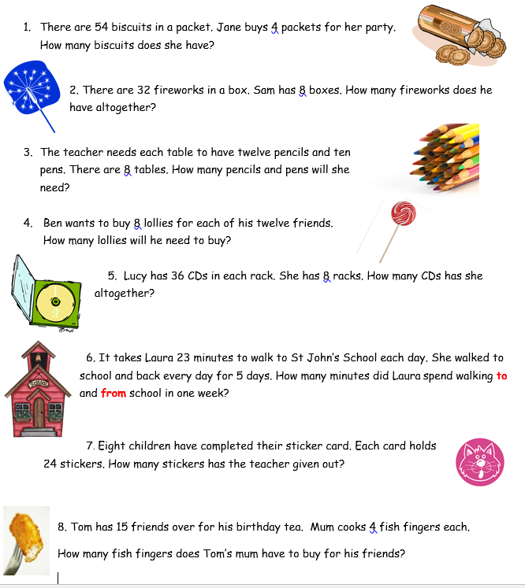
There are quite a few word problems to work through here Class 3. Do as many as you can. I’d recommend 5. Use a column multiplication please.
Answers

1. 216 biscuits
2. 256 fireworks
3. 12 x 8 = 96 pencils 10 x 8 = 80 pens 176 altogether
4. 96 lollies
5. 288 CDs
6. 230 minutes (23 x 5 = 115 x 2 = 230 minutes) or 46 x 5
7. 192 stickers
8. 60 fish fingers. Remember a quick way to multiply by 4 is to double and then double again.

