**RE Knowledge Organiser – What kind of a king was Jesus?**

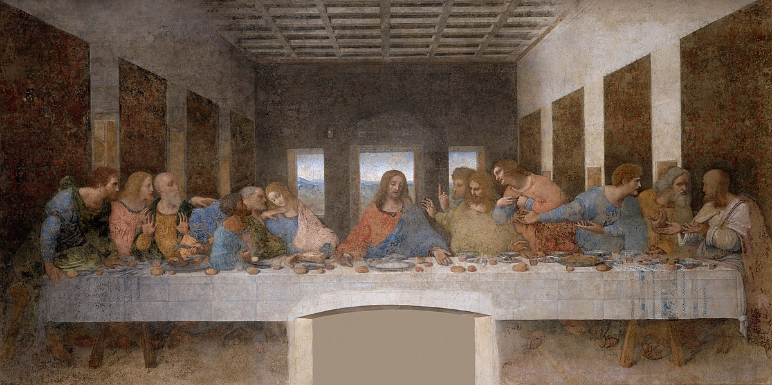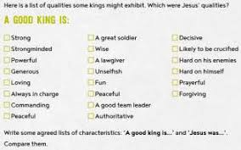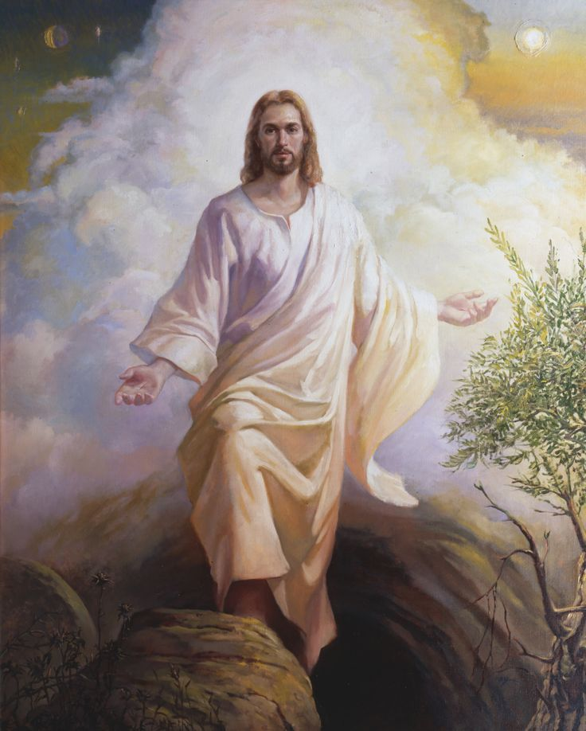

*In this unit, we discuss what sort of a king Jesus was. We will look into what sort of kingdom Jesus wanted, some of the key events in Jesus’ life and what his actions taught us about the kind of king he was.*

**Key Vocabulary**

**King** – a ruler

**Kingdom** – a spiritual reign of a God

**Bible** – the religious text in Christianity

**Christianity** – the followings of the teachings of Jesus Christ

**Jesus** – the Son of God