The Olympic Games are a great opportunity for the world to come together in the spirit of friendly competition. Nowadays, there are many types of Olympics to ensure everybody gets an equal chance. To find out more about the Modern Olympics, continue reading.
When were the first Modern Olympics held?
The first modern Olympic games were held in 1896, in the Greek city of Athens. This was after a French man named Pierre de Coubertin had drawn inspiration from the original Greek Games and created the IOC (International Olympic Committee) in 1894 in Paris. The first games marked an extraordinary adventure that has now lasted over a century.
Who can take part in the Olympic games?
Being able to take part in the Olympics is a dream for many young and budding athletes. Everybody is given the opportunity to be able to take part in the Olympic games but it is the will power, natural talent and dedication that will enable the world’s elite to showcase their talents on a global stage. Taking part in the games is what matters to the majority of competitors: having the honour of representing their country and marching behind their flag during the opening ceremony. This is what the spirit of the Olympic Games is all about.
What types of sports are evident at the Olympic games?
Unlike the Ancient Olympic Games, where there were only a few events, the modern Olympics have developed so much that, now, there is even a Winter Olympics (alternate every two years with the Summer Olympics) where most of the events take place on snow or ice.
During the summer games, there are over 301 events; athletics and swimming being the most widely followed. The athletics consist of a wide range events: jumping, throwing, sprint, middle-distance and long-distance races.
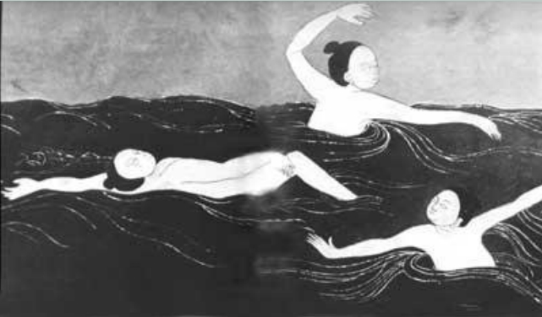
Did you know
In the first Modern Olympics, the swimming events all took place in the sea or in the rivers.

What if you win?
In the beginning, Olympic medals varied from one Olympiad (every four years) to the next. In the first modern Olympics, in Athens, 1896, to replicate the original Ancient Games, the winners were awarded with an olive wreath and a silver- medal while the runners-up were awarded a laurel wreath and a bronze medal. The traditional gold, silver and bronze medals were not established until 1904.
The Olympic games continue to captivate people all across the globe and long may they continue to do so.

