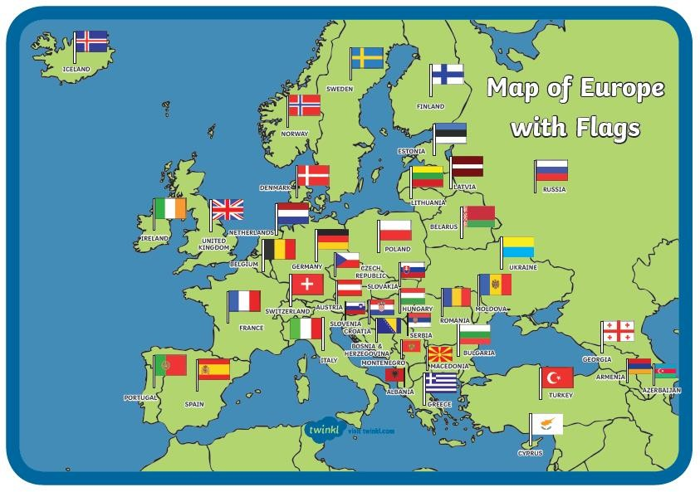

**Capital** - the city or town where the government runs the country from.

**Continent** – a very large landmass of countries. There are seven.

**Country -** a nation with its own government, occupying a particular area of land.

**Human geography** is about buildings, roads, farms, etc. Things that have been made by humans.

**Major city** - an important, large, or high performing city.

**Physical geography** is about the natural World; mountains, seas, rivers, forests etc.

**Territory** – a plot of land controlled by a specific person, or country.

