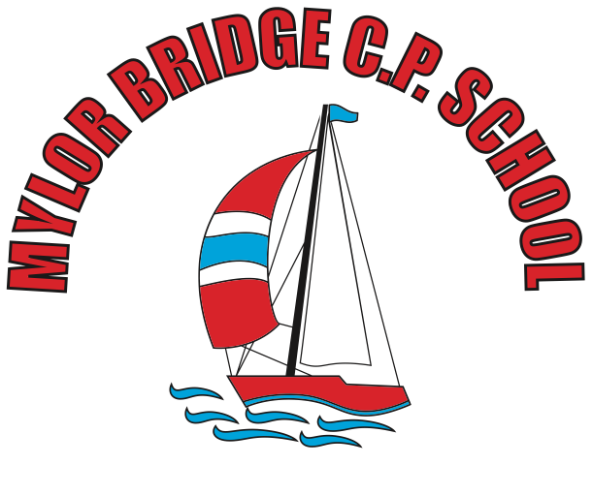
Summer Learning Projects Theme: Environment
Year 2
English | - Write a ‘thank you’ letter to the people who collect your rubbish and recycling. What could you include in your letter? Can you think of any questions you could ask about recycling or where the rubbish goes?  - Can you label the plants in your garden or in the house?  - Write a weather report. Can you use any adjectives?  - Write a set of clear instructions on how a rainbow is made.
Maths | Work through Maths booklets.
Topic | The project this week aims to provide opportunities for your child to learn more about the environment. Learning may focus on changes to different environments, the impact of humans on environments, climate change etc .  Create a chart to record the weather. Label the chart with days of the week and record the weather at different points in the day. Can you write down key words and take a photograph of the sky. Does it change in the week? This link may help.  Watch the weather report on T.V. How do they describe the weather? What do you notice about the map? Can you find Cornwall on the map? Have they got symbols when they are talking about the weather?  Weather reporter: Pick a day that you would like to present as a weather reporter. Can you create some symbols to use when you are talking about the weather? Can you talk about the weather in your local area and maybe compare to another place in the UK?  Create a weather wreath. Using different materials can your child design a weather wreath? Encourage them to think about the symbols used in your weather report.  What a load of rubbish! With your child look at the rubbish as a family you throw out. Do you help to recycle? How do you sort these into junk and into recycling? Look at the range of items and group them into different material groups. Talk to a family member about how certain groups are plastics and can also look and feel different to each other. Could you design a new way to help recycle more items? Ideas  Beat the clock- Can you sort items into the correct recycling and waste bins? Play  Switch it off: Ask your child to take a look at all the electrical devices in their house. Are they all plugged in? Do they need to be plugged in? How could they create a poster to place around the house to help remind people to switch it off once they have finished.  Save Electricity, Recycle Paper, Conserve water. What could you include on these? Where could you place these in the house? Can you talk to your family about the posters and how you could help the planet?  Listen to a song about things we can do to help to save the planet.  Write and draw! Ask your child to choose one thing they could do to help the environment in school. Get them to make a poster to encourage people to do it! Think about the classroom and also the school.  World Environment day- This year it was on Friday June 5th. On this day, people from all over the world do something positive to help our planet. Ask your child what could they do. Lots of little things can make a big difference. What could they do to celebrate World Environment Day at school next year? Can they create a poster to display at school?

