Context of the School

- The current NOR is 146: 57% boys (84)and 42% girls (62)
- In year movement: 1 x 1 Y1 girl, 1 x 1Y2 girl.
- 3.42% eligible for FSM 5/146
- 19.86% 29/146 in receipt of Pupil Premium (below the national percentage of 27%)
- 0 x EAL
- Children with medical conditions 6.16 % 9/146 n
- CIC X 2 children 1.37%
- G+T 4/146 19% (all in Y6) Action VS to investigate G+T criteria
- SGO x 1 child (2x in Spetember)
21% SEND (21/146 children) (ABOVE national figures of 16%) We currently have 2 children with an EHCP (replacement of the Statement of Special Educational Needs) (1x in September)
- The school is in the most deprived 40% as indicated by the indices of multiple deprivations.

Overall Absence in %
2014 |  | 2015 |  | 2016 |  | 2017
 | 94% National Average |  | 95% National Average |  | 95% National Average | 95.6%  Authorised: 3.6  Unauthorised: 0.8 | 95% National Average

Please note:
- SEND absence I s 91%
- PP attendance is above none PP
See Attendance Officer’s report

From September 2017
Class 1: EYFS -20 Year 1 - 10 | Mrs Mogridge  Mrs Tressider (Mon- Thurs 9.00 – 3.15)  Mrs Hatton (Mon- Fri 9.00 – 2.00)  Miss Revel (Fri 9.00 – 3.15)
Class 2: Year 1 – 11 Year 2 – 20 | Mrs Lang (Mon- Wed) Mrs French (Thurs- Fri)  Mrs Mitchell (Mon – Thurs)  Mrs Armstrong (Fri)
Class 3 Year 3 - 19 | Mrs Thomas  Mrs Armstrong (Mon – Thurs)
Class 4 Year 4 - 19 | Mrs Wilks  Mrs Lane
Class 5 Year 5 – 22 | Mr Colinge  Mrs Evans (Mon/Wed/Thur/Fri am)  Mrs Fenton (Tues/ Thurs pm)
Class 6 Year 6 - 22 | Mr Martin  Mrs Fenton Mon- Fri am + Mon/Wed/Fri pm
PPA Cover | Mrs Curnow – Wed- Fri

Significant Changes/Challenges Since the last Head Teacher’s Report

- CL has retired, VS has commenced as substantive Headteacher
- KH has successfully completed her ITT and has resigned from post - as of the 31st August, in order to continue her teaching career.
- MB has resigned from post to take a position in the care industry
- JF will begin her ITT in Sept – her contract terminates in July 17.
- VC’s contract has been reduced to 0.6 as of Sept 17
- Fund raising committee re-established
- Awards for all grant has been applied for - see School-Scapes plan.
- Tesco Bag of Help grant successful – amount TBC Sept 17. Monies for Huff and Puff equipment

Early Year Provision
EYFS:
End of year: GLD = 15/20 75% Last year 88% - National 66%

- Sept 17: 20 EYFS with 1 on appeal for a place
- Big focus on school –readiness, including promoting resilience and independence, phonics and early number work.
- Tapestry –online learning journey, to be used to record learning and to engage parents.
- Parents open afternoon was positive.

Outcomes for Children

Phonics Screening Test (PST):

Year 1 Current Cohort Sch: 75% National: 77%

Year 2 Current Cohort: 2/4 retakes achieved pass mark

KS1 Attainment:
Children achieving level 2 + / from 2016 @ NARE

Year | Reading |  | Writing |  | Maths |  | SPaG
 | Sch | National | Sch | National | Sch | National | Sch | National
2016  (National Age-Related Expectation) NARE | 79% | 74% | 68% | 65% | 74% | 73%
2017 | 75%  15/20 |  | 75%  15/20 |  | 65%  13/20 |  | 45%  9/20

TA Assessment of greater depth
Year | Reading |  | Writing |  | Maths |  | SPaG
 | Sch | Nat | Sch | Nat | Sch | Nat | Sch | Nat
2016 | 42% | 24% | 0% | 13% | 16% | 18%
2017 | 25%  5/20 |  | 20%  4/20 |  | 5%  1/20 |  | 10%  2/20

KS2 Attainment:
Children achieving NARE Standardised score of 100 +

Year | Reading |  | Writing |  |  | Maths |  |  | SPAG
 | School | National | School |  | National | School |  | National | School |  | National
2016 | 71% | 66% | 79% | 74% |  | 92% | 70% |  | 75% | 72%
2017 | 81% 17/21  TA:  86% 18/21 | 71% | 76% 16/21 | 76% |  | 86% 18/21  TA:  91% 19/21 | 75% |  | 86% 18/21  TA:  91% 19/21 | 77%

Children achieving Greater Depth @ 110 + standardised score

Year | Reading |  | Writing |  | Maths |  | SPAG
 | Sch | Nat | Sch | Nat | Sch | Nat | Sch | Nat
2016 | 29% | 19% | 21 | 15% | 33% | 17% | 38% | 22%
2017 | 38% 8/21/  TA: 43%  9/21 | TBC | 38% | TBC | 38%  8/21  TA: 43%  9/21 | TBC | 52%  11/21  TA: 57% 12/21

Quality of teaching, learning and assessment

- In September we will use a triangulation model to monitor standards of teaching i.e: lesson observations, book and planning scrutiny and pupil conferencing. This is a cyclic programme of assessment and feedback. (See yearly overview) Which initially will be carried out by VS and AM, with the view to involve TL/JT/AM/MC (as English and Maths Leads) in 2018-19

- OFSTED Feedback: To improve the teaching of Modern British Values – from September staff will be asked to indicate on planning where British Values will be discussed.

- In September staff will note on planning opportunities to discuss the 5 areas of Bristish Values. These will be age-specific and topic-based.

- A focus on growth mind-set and resilience in our learning is to be developed – with children using coaching-style conversations to aid problem solving (Training with Healthy Schools Cornwall - October 17) .
- Focus in immediate feedback and Purple Polishing has been introduced – anecdotal feedback suggests that children are finding this useful, though more formalised pupil conferencing will take place in October – see yearly overview.

- OFSTED ACTION:
Precise planning leads to effective support for pupils who need to catch up to attain in line with national expectations

- Termly pupil progress meetings will take place to review and update intervention allocation and re-focus teachers on those children not making the right levels of progress and/or attainment.
- Intervention trackers will focus on personalised ‘gap-filling’ to take place. We have also ensured that ‘same day’ intervention takes place in order to ‘mop-up’ any misconceptions.
- Interventions focussing on Phonological Awareness will be high profile- with TA training having taken place this half term, in preparation for a September start.
- Assessment: Some changes to assessments mean that we now complete a distance piece of writing every 3 weeks (or twice per half term) . This is to ensure that we have enough evidence of our teachers’ assessment when grading them children at the end of the year.

- PPA cover in all classes will be covered by Mrs Curnow to ensure high quality input and behaviour for learning.

Personal Development, Behaviour and Welfare

Behaviour logs show that there a few children who repeatedly present difficult behaviour. These chldren are all well-known to staff and 4 of these children have specific behaviour agreements, signed by parents. When poor behaviour does occur, the consistent inplementation of the behaviour policy ensures that all staff feel empowered to manage these situations. There have been no fixed term exclusions this year to date.
Incidents of poor language on the playground have reduced over the last half term.

- Anecdotal feedback from parents and visitors speaks of well-behaved and eager learners who are enthusiastic about school and enjoy their learning. Pupils who are polite and well-mannered.
- A strong PSHE curriculum (which encompasses SRE and resilience) will be introduced in September. This will ensure that children are able to make and retain friendships allowing children to manage social situations well.

- We celebrate children’s achievements in weekly celebration assembly which will be opened to parents in September.

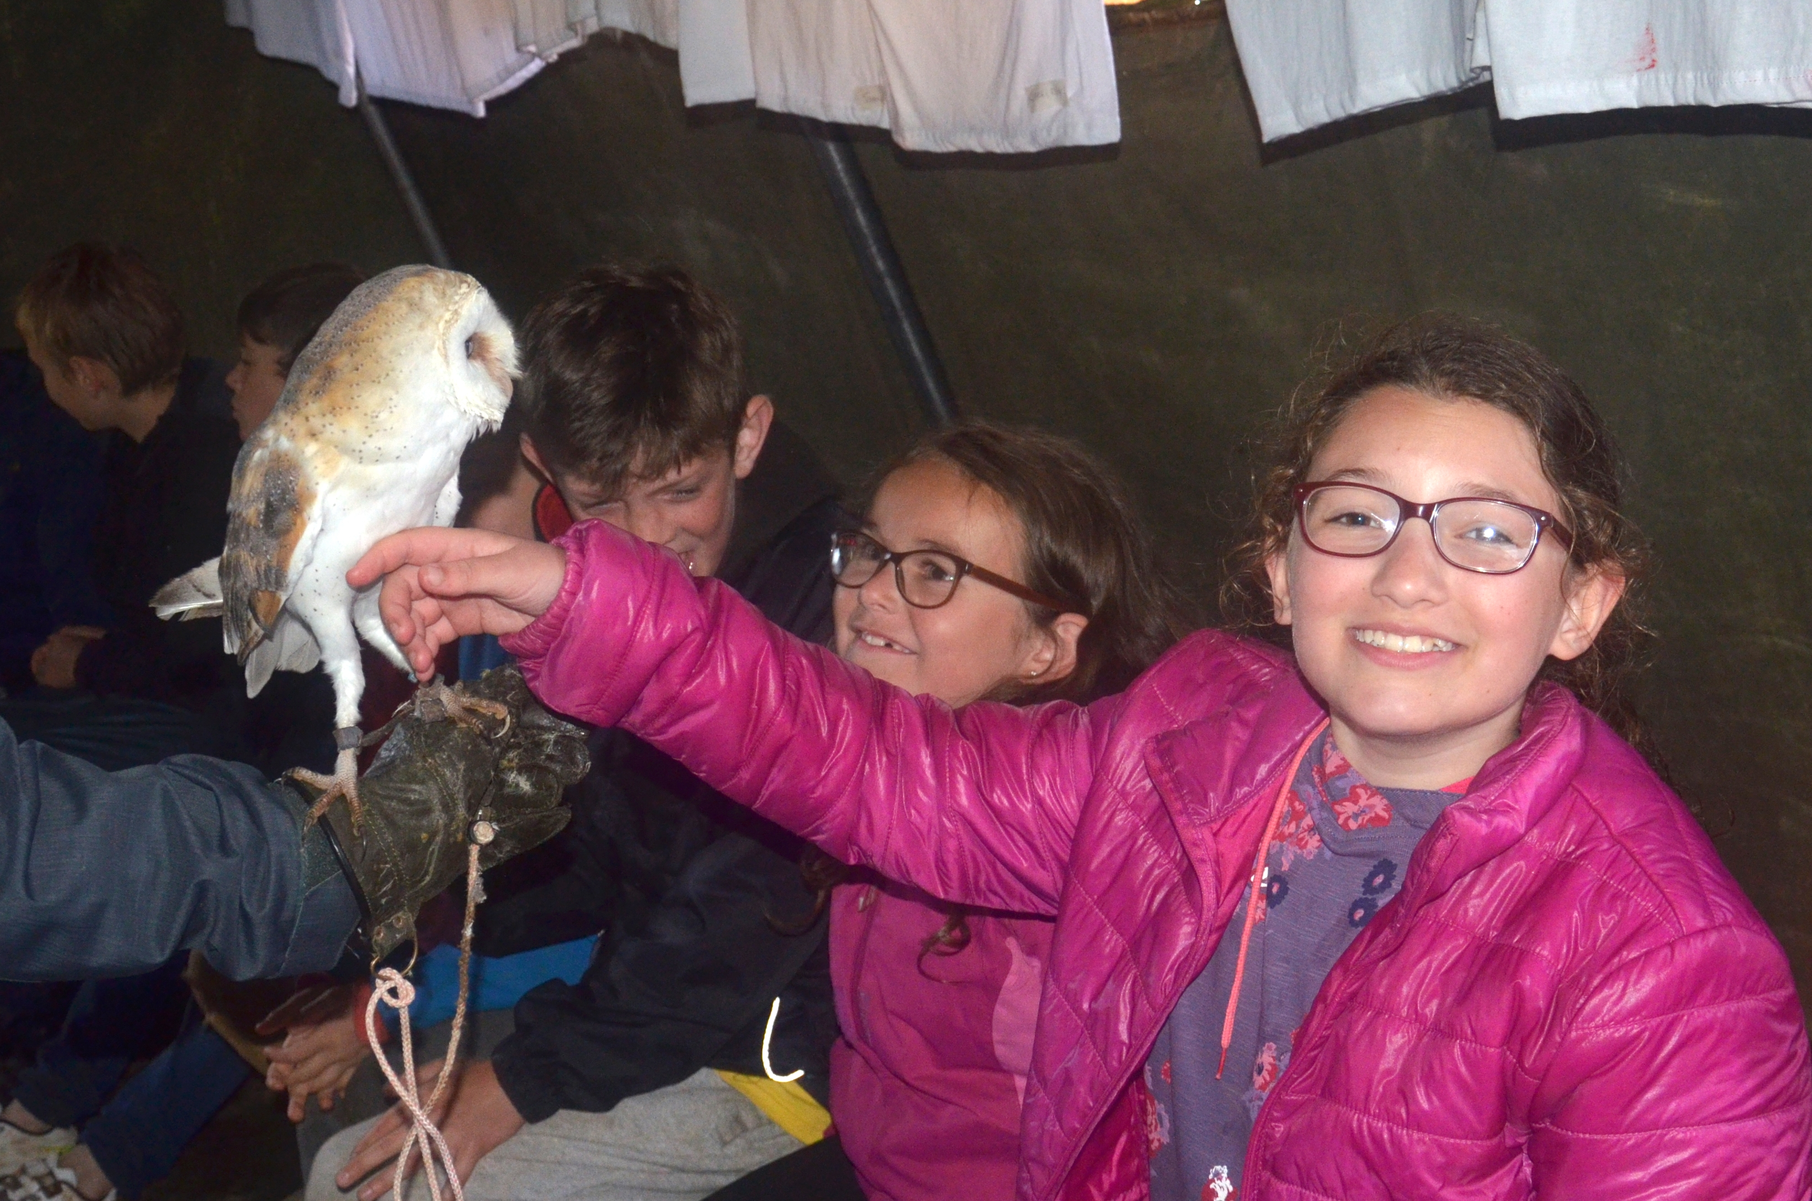
Since April the children have had the following opportunities:
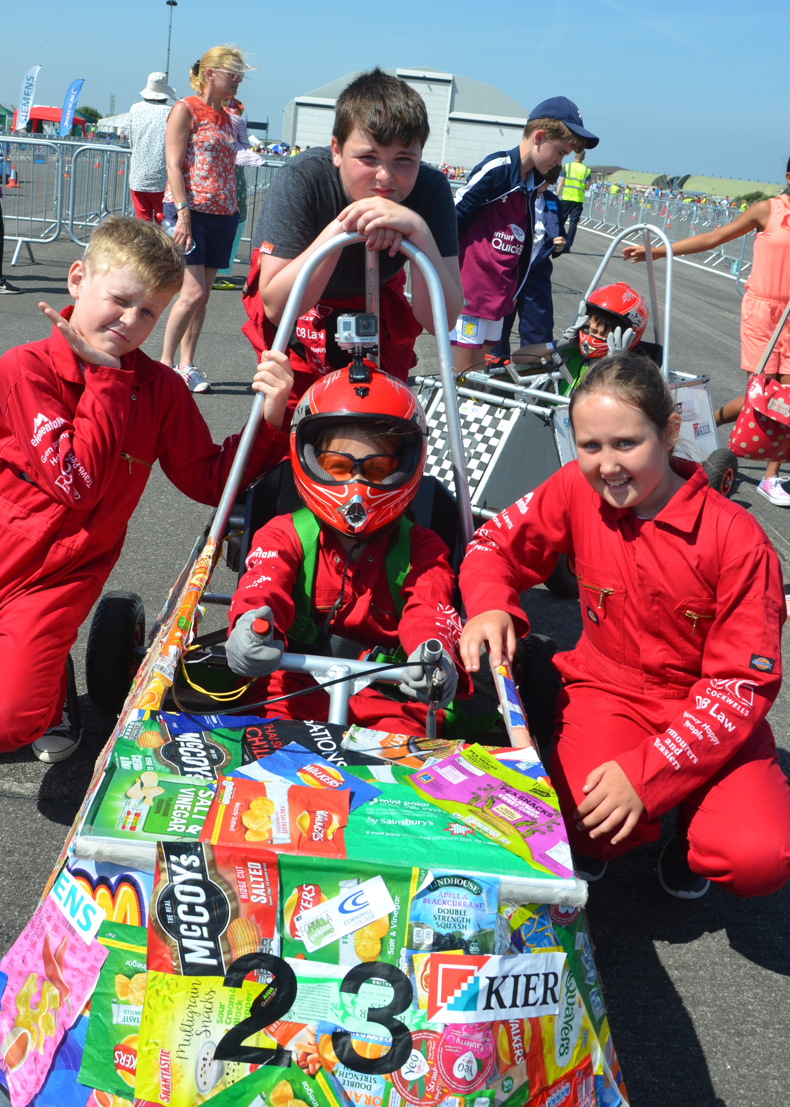
Y4: Trip to Mylor Church
Y3 and Class 2: Visited Mylor Chapel
Y4: Museum Residential
Y5: Camp Kernow
Y6: Canoe Cornwall
Class 2: Visit to PD’s farm
Class 1: Country walk
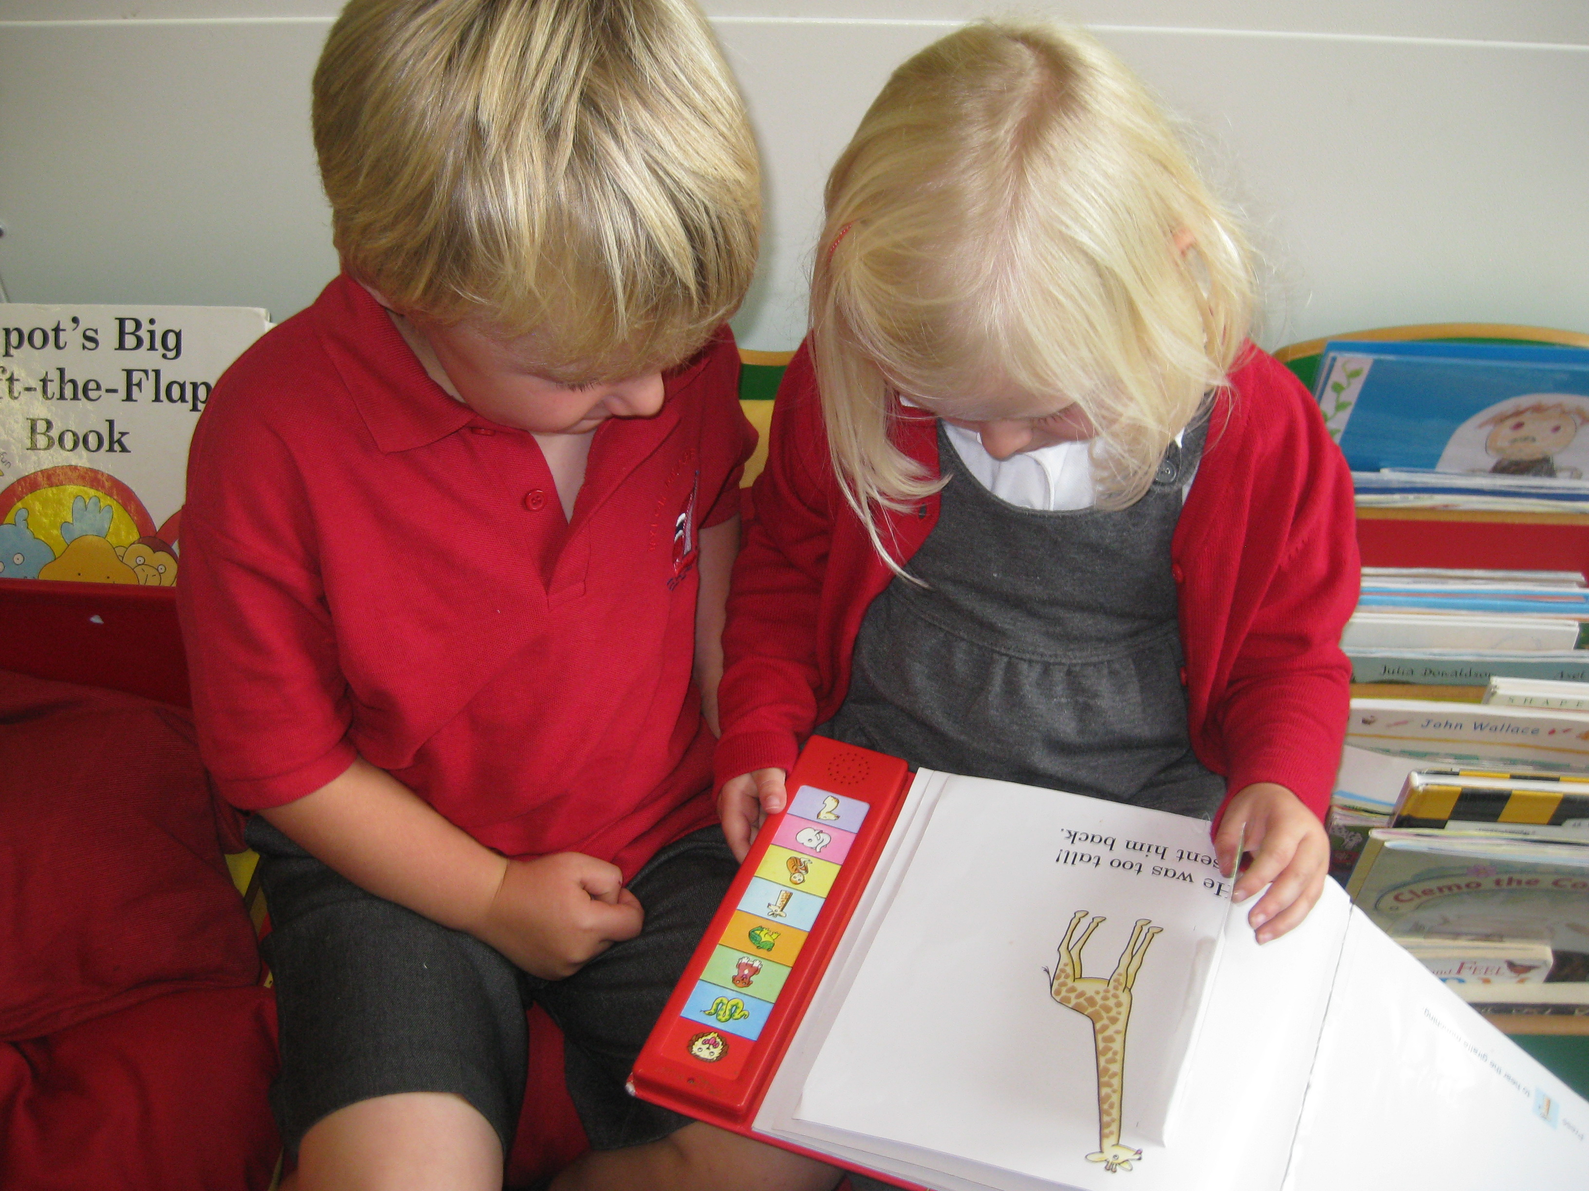
Year 5: 2 x Science days @ Penryn College
Year 4: Dentist Visit
Year 5: Gwenap Pit
Year 3: Boat Tour
Year 5/6: Cricket Tournament
Year 5/6: Girls football
Year 6: Goblin Green Power Race Cars

Parents have also been offer on-line safety training and Learning Together Opportunities, alongside an Open Door Policy to discuss concerns with VS.

Effectiveness of Leadership and Management

The leaders’ and governors’ vision and ambition for the school are evident through our ‘The Best We Can Be’ moto. This is explicitly referred to throughout teaching times and in assemblies. The children recognise and celebrate effort and achievement of themselves and others. For example: Y6 winning the Goblin Green Power Race Event

High expectations and a culture of can-do is being developed here at Mylor – in September Learning and Teaching strategies will be agreed and staff will use these to understand their accountability for learning within the classroom and beyond. Staff appraisal will be rigorous, with a cyclic evaluation programme for teaching and learning. Where high quality teaching is evident this good practise will be shared.

Action: A curriculum review for English and Maths needs to be completed to ensure coverage and ensure that teachers are building on from previous learning.

The English Leads (JT/TL) and Maths Leads will be beginning to monitor curriculum and coverage throughout 2017-18. This will include pupil conferencing and book-looks.

July 24th see all staff involved in reviewing this year’s SEF and sharing ideas for next years SEF and SDP – ALL GOVERNORS ARE WARMLY WELCOMED TO THIS MEETING. Once written this SEF and SDP will be reviewed termly with teaching staff and twice yearly with non-teaching staff. They will both be RAG rated to ensure priorities are clear for all.
Staff will begin to take ownership of the SEF and SDP – especially in the reviewing of targets.
CPD is thorough and linked to the SDP. Staff and most governors have all completed safeguarding (Tier 2)

All teaching staff and HLTAs have areas of responsibility:

- Mrs Mogridge: EYFS
- Mrs Lang: English
- Mrs French: Science
- Mrs Thomas: English
- Mrs Wilks: SENCo
- Mr Collinge: Maths and Science
- Mr Martin: Maths
- Mrs Lane: ICT
- Mrs Fenton: Learning Mentor

- From September all TAs will be asked to run specific interventions – as detailed by Mrs Wilks

CPD from April – July
- TW/ KH/ VS visited Carclaze Primary re: PA intervention
- AM/JT visited Parc Eglos re: Marking and Feedback
- AM/TW completed Team Teach training
- TW Completed Safeguarding Tier 3 training
- KM/TL/AM/DM/JH to complete Tapestry Training 13th July
- Whole staff Tier 2 safeguarding training
- Governor Tier 2 safeguarding training

MAT Update:
After PD and I had a lengthy and honest conversation with MH (CEO Kemeneth) we are hoping to continue our exploration of converting to a MAT with Penryn College, Mawnan Smith, Flushing and Perran ar Wortha. There is also a meeting on the 11th July – I will update governors as to the outcome of this meeting during our FGB meeting.

