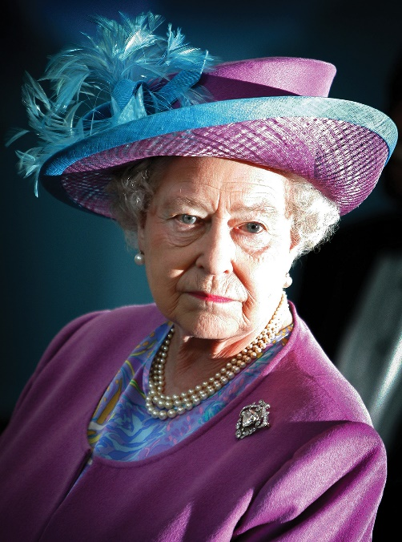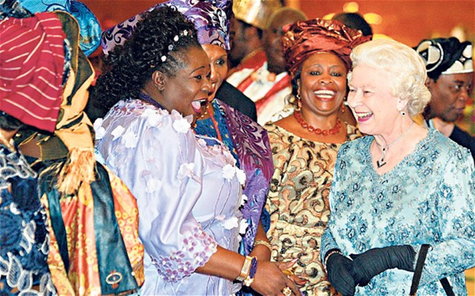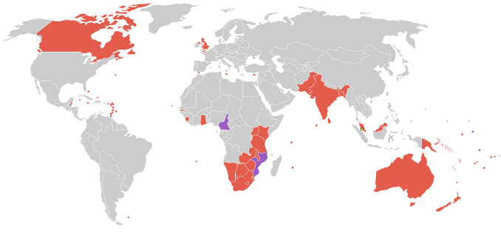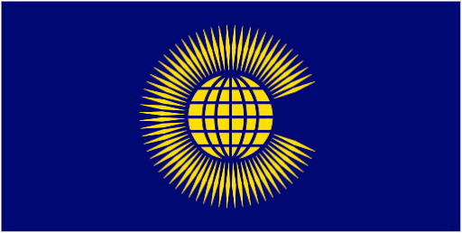

**Key questions**

1. **When was the Commonwealth first established?**
2. **Currently, how many Commonwealth nations are there?**
3. **Why was the Commonwealth established?**
4. **Can you name at least five countries in the Commonwealth.**
5. **Do you know what the Commonwealth charter is?**
6. **Can you explain how the Commonwealth nations are interconnected and interdependent?**
7. **What is the largest nation in the Commonwealth by population?**
8. **What types of products do we trade in Great Britain?**
9. **What are the main values of the Commonwealth?**
10. **Can you name a key sporting event that the Commonwealth supports?**

Our Queen is the Head of State of the Commonwealth

The map to the left shows the nations of the Commonwealth.

The Commonwealth flag

**Key Vocabulary**

* **The British Empire – Colonies formerly ruled by the United Kingdom**
* **Trade** – **The action of buying and selling goods or services.**
* **Interconnected – Having parts linked or connected in someway**
* **Interdependent –Countries are depending on each other more and more.**
* **Natural resources - Materials or substances occurring in nature which can be exploited for economic gain.**
* **Economic –** **How society uses it resources and linked to a countries wealth.**
* **Charter – A written document outlining the rights and the responsibilities of in this case a country.**
* **Commonwealth - An international association including the UK, some countries that used to belong to the British Empire as well as other states that have joined and signed the charter.**
* **Flag - A symbol or emblem of a country.**
* **A union – A joining or the fact of being joined together.**
* **Respect -** A **due regard for the feelings, wishes, or rights of others**

**The Commonwealth**

**Year 5– Knowledge Organiser**

**Materials**