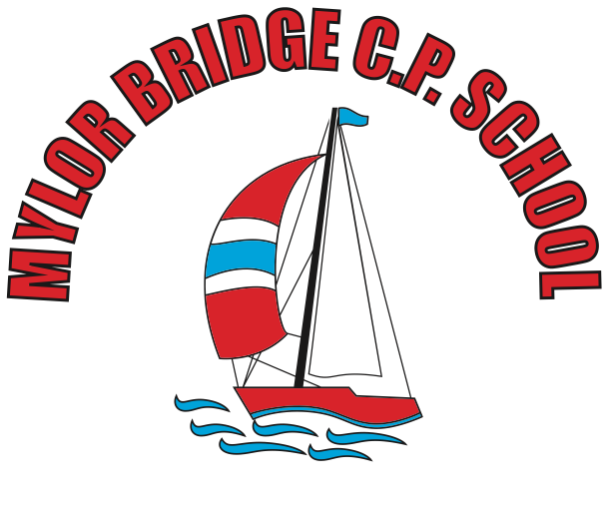
Summer Learning Projects Years 3 & 4 Theme: Transport
English | Reading Task – Click here to read about modes of transport.  Writing Task - Ask your child to read the poem ‘Look at the Train!’ They can write their own poem about a mode of transport using onomatopoeia (when a word describes a sound and mimics the sound of the object/action) to evoke sounds and rhythm.
Maths | Journey to the park and bring a picnic. Help your child to practise reading scales by measuring the mass and capacity of ingredients in a home baking recipe! Encourage them to use maths to calculate measurement totals or convert between units of measure.
Topic | The project this week aims to provide opportunities for your child to learn more about transport. Learning may focus on modes of transport, transport in the past, the science behind transport, road safety and how to be safe around water.  Transport Inventors - Ask your child to find out about famous transport inventors such as Henry Ford and The Wright Brothers. Create fact files about these inventors. Can your child draw sketches of different modes of transport then and now. Can they place different modes of transport on a timeline using their invention date?  Colourful Collage - Ask your child to create their own transport collage. Encourage them to draw, colour or paint a variety of vehicles or make a large collage of one vehicle. Ask them to use bold colours to really make their vehicles stand out! The collage could be made using cut up squares from magazines and leaflets.  Obstacle Course - Ask your child to find any toy transport (cars, trains, etc) they may have at home, then they can design an obstacle course for their vehicle to travel around. This could be on a track or floor involving ramps inside or in the garden. Another idea - get each family member to make a paper aeroplane and throw each one in turn and see whose travels the furthest. Ask your child to measure the lengths of the distance travelled and record these on a bar chart.  Let’s Talk Transport -Talk as a family about transport in your life. Talk about how you get to school and work. Do you get your food delivered? Does anyone in the family operate a mode of transport? Is it their job? Discuss the first family car owned. Ask your child to mind map all of the ways your family relies on transport and then to imagine a life without it.  Transport Around the World - Ask your child to look at how people travel around in India. Buses, cycle-rickshaws, autorickshaws, e-rickshaws, tempos (big, brutal-looking autorickshaws), taxis, boats, tongas (horse-drawn carts), metros and urban trains provide transport around India's cities. Encourage them to compare this to Venice and how the people there travel around (gondola and sandolo tours all around the city). Can your child design a new vehicle suitable for each of these places thinking carefully about suitable and local materials?

