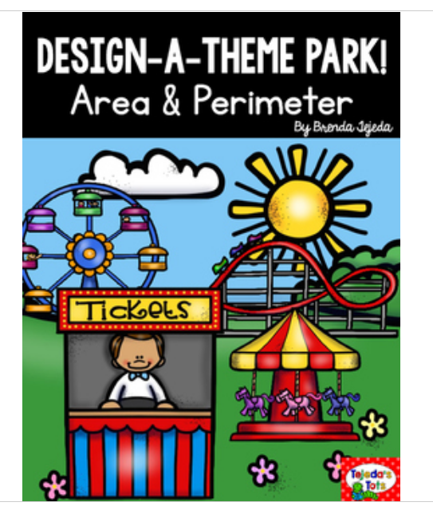

Here are some samples of what it might look like. The pictures are not clear, but you can create your own key using your own pictures or symbols.
For example: 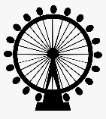 or 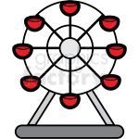

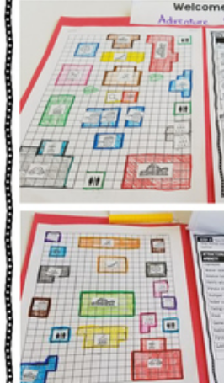

You will need to complete the task following the instructions and then complete the ‘funfair table’ at the end, where you will need to fill in your area and perimeter measurements.

