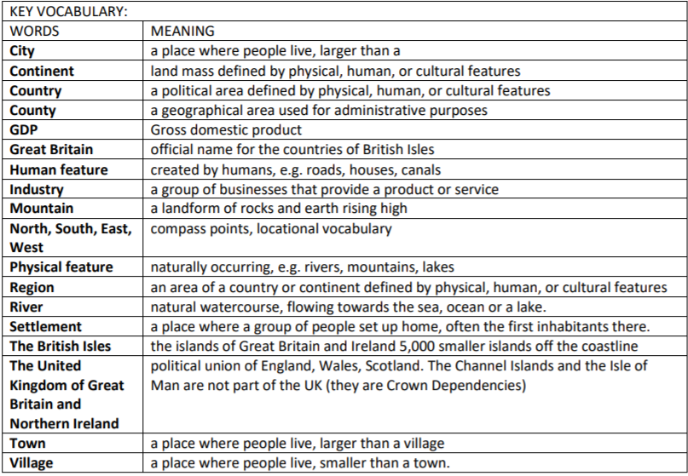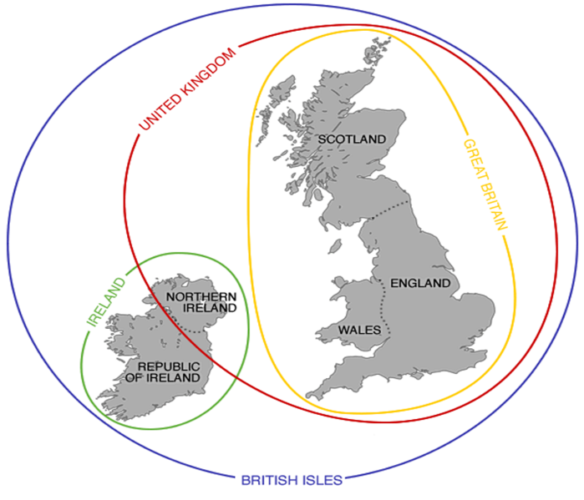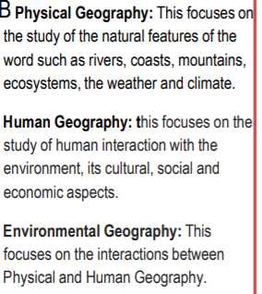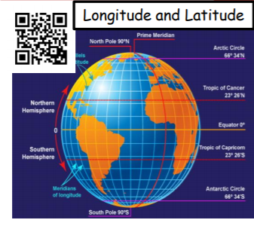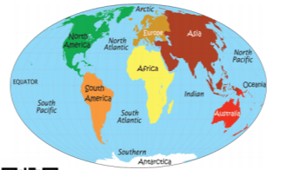

**What is the difference between the UK, Great Britain and the British Isles?**

**The British Isles Knowledge Organiser Geography**

**Key Questions**

1. **Can you name all the continents?**
2. **Can you name at least 10 countries?**
3. **Can you locate the UK on an atlas?**
4. **Which continent is the UK a part of?**
5. **Can you name the Oceans, a famous river and a mountain?**
6. **What is the name of the highest mountain in the UK?**
7. **What is the difference between, the UK, the British Isles and Great Britain?**
8. **Can you name some of the key human and physical features of the UK?**
9. **Can you name some of the regions in the United Kingdom?**
10. **Do you know some of the counties of the UK and what they are famous for?**

The **continents** and **oceans** of the world.

A continent is one of the earth's seven major areas of land. The continents are Africa, Antarctica, Asia, Oceania/Australasia, Europe, North America, and South America.

An ocean is a huge body of salt water. Oceans cover nearly 71% of Earth's surface. They contain almost 98% of all the water on the Earth.

There are four main oceans on Earth: the Pacific, the Atlantic, the Indian, and the Arctic.

**What is Geography?** People who study geography are called geographers. Geographers are interested in Earth's physical features, such as mountains, deserts, rivers, and oceans. They are also interested in the ways that people affect and are affected by the natural world. The study of Geography is split into:

**Physical** **Human**  **Environmental**