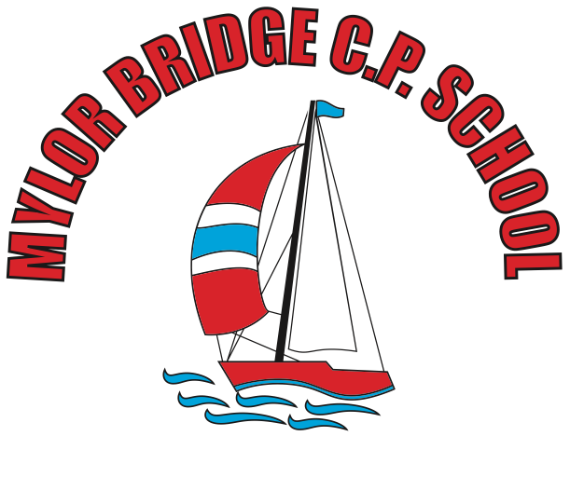
Summer Learning Projects Years 3 & 4 Theme: Music
English | Reading Task - Look with your child at this poster pack of musical styles. Read through the information for each musical style and find a song to listen to. Ask your child to identify their favourite music styles giving reasons for their choice.  Writing Task - Listen to the piece of music called Peter and the Wolf written by Prokofiev. Whilst listening, encourage your child to list any words that come to mind e.g elation, cheerfulness. They could also draw a picture of what they think the song represents.
Maths | Maths - Ask your child to become a shape scavenger! How many examples of different 2D and 3D shapes can they find around the home/garden? Can they create a tally and sort the shapes they find based on their properties? e.g. number of sides/edges, number of pairs of parallel lines.
Topic | The project this week aims to provide opportunities for your child to learn more about music. Learning may focus on famous musicians, listening to and performing music and exploring a range of music genres and instruments.  Lean On Me - Encourage your child to listen to Lean On Me, a Soul/Gospel song by Bill Withers. Do they like it? What instruments can they hear? Can they clap a rhythm? Learn to sing the lyrics and have a go at performing the song. Perhaps your child would like to research this famous artist in more detail and listen to more of his songs, creating an artist profile complete with portrait sketch. Perhaps they could perform the song to a family member via Facetime (with adult supervision)?  Musical Makes - Ask your child to try creating their own music instrument. They could make their own pan flute using straws, a cereal box guitar, or some tin can drums. Encourage them to plan their design first, source materials from around the house, write the steps to make the product and then evaluate it afterwards. Or they could research Kandinsky and create their own instrument art inspired by his work whilst listening to different genres of music.  Feel the Beat - Why not ask your child to have a go at moving their body to different genres of music. As you change between Rock, Jazz, Hip Hop, Heavy Metal and Classical music, how does the way they move their body change? Have a dance together to the beat of the music!  Listen Together - Encourage your child to ask each family member what their favourite song is. Play the song aloud and listen together. Spend some time as a family discussing what genre of music the songs belong to and how each piece of music makes you feel. Which genres of music were the most popular? Can your child represent their results in a bar chart. They could ask family members to rank their favourite genres of music first.

