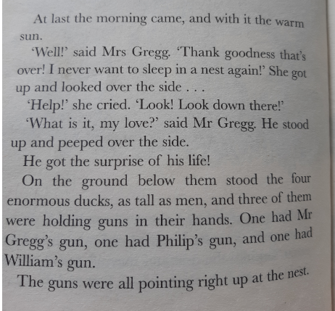
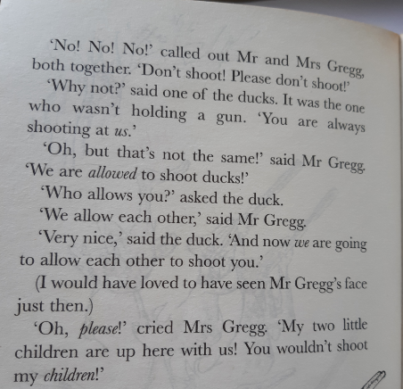
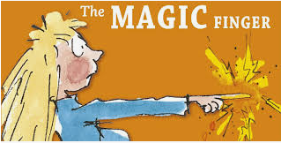
Pg2
Pg1

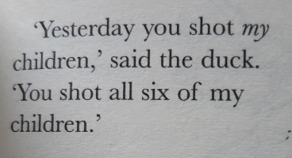
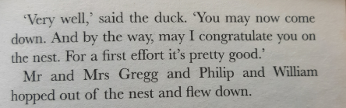

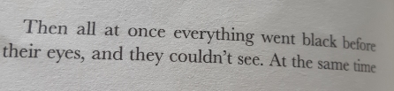
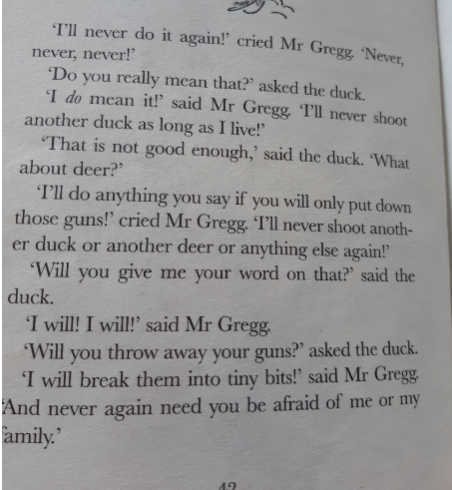

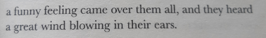

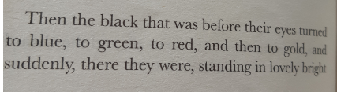

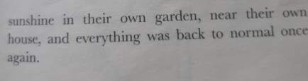

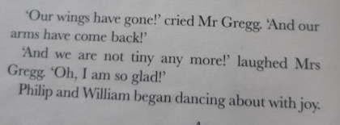

Pg4
Pg3
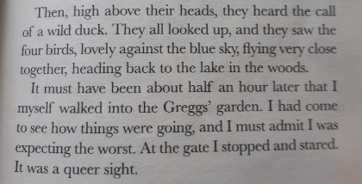

Pg 5

Vocabulary | 1a. What word means looked? pg1
 | 1a. What words means shock? pg1
 | 1b. What word means huge ?pg1
Inference | 2.Why is Mrs Gregg upset? Pg2
Predict | 3.What was the queer sight? (remember queer means odd – so something odd was happening in the garden, what do you think it was?) pg5
Explain | 4. Explain why the ducks want Mr Gregg to break his guns. pg3
Retrieve | 5.Where do the ducks fly?
Sequence | The ducks point guns at the nest
 | The ducks fly away
 | Mr and Mrs Gregg and the children lose their wings
 | Mr Gregg promises not to shoot another creature

