The Sheep and the Goat - Questions

- Why did then sheep want to build a house in the forest?
____________________________________________
- Find and copy a word from the text that can mean:
  - looking - ________________________
  - picked up - ________________________
- Which word best describes how the sheep spoke to the goat at the beginning? Circle one.
  - Chilly c. unhappily
  - Suddenly d. steadily
- Why did the wolf creep into the house?
------------------------------------------------------------------------------------------
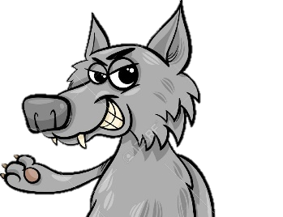
- Match up the animal with what they did.
Sharpened the posts
Grabbed the bricks
Covered the walls
Hammered the roof
Goat
Sheep
Hare
Cow

- What do you think the wolf will do next?
________________________________________________
- Would you prefer to live on the hillside or in the forest? Why?
Hillside Forest
________________________________________________________________
____________________________________________________________________________________________________________________________

