The modern Olympics

Every four years, Olympiads from all over the globe compete in different games, doing this can win you gold medals, that will make your country proud! But even if you didn’t win you still get to be an Olympiad.

When and where was the first Modern Olympics?
Happily, Pierre De Coubertin was the man who thought there should be a modern Olympics so there is now, even though it was done by people in Athens Greece 1896 he followed on from that.
Who can take part in the games?
If you want to be in the Olympics you couldn’t just turn up there on that day could you now? You had to do at least four whole years of training! And you couldn’t go at a young age could you, because you wouldn’t want a 4 year old coming!
What sports were played?
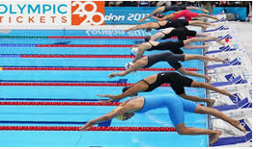
Nowadays, we play sports like running, jumping and other things. But in the Ancient games people did it naked! And did things like short foot races in amour, medium foot races and long foot races, so it didn’t sound that long to me!
Did you know?
Two favourites were swimming and Athletics.

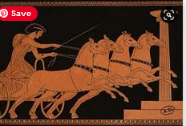
Medals and prizes!
When we win prizes at the Olympics we get to win 1 gold medal in 1st place, 2nd is silver, 3rd is bronze and if you don’t win you get the chance of being an Olympiad. But in the Ancient Olympics if you were 1st you won an Olive wreath.
What will happen in the future?
Glossary :
Olympiads: An Olympiad is a person who is in the Olympics.
Nowadays: This means the present day.
Glossary: a box of words you might not know that’s in the text.
Personally, I think the Olympics will either get more lazy like running on running machines to see how fast you can do it or get much more sporty. But you never know.

