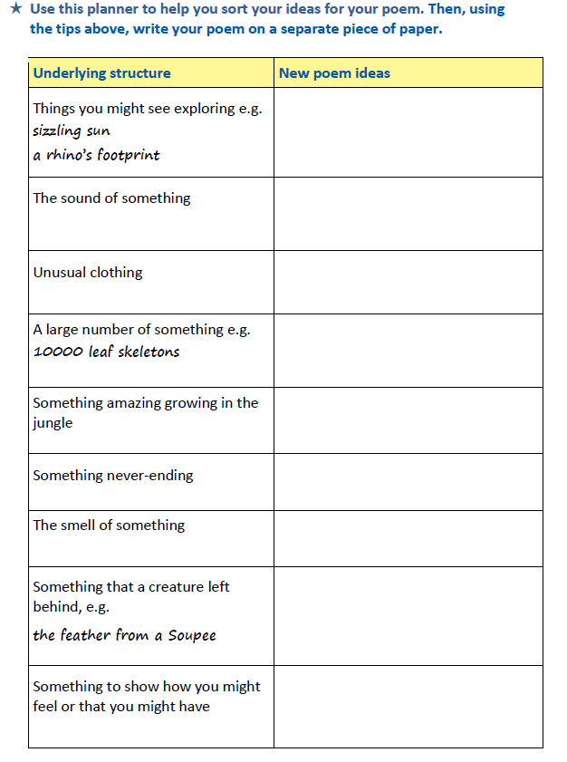

WALT use a planning grid to help us plan our list poem