Science at Mylor Bridge CP School
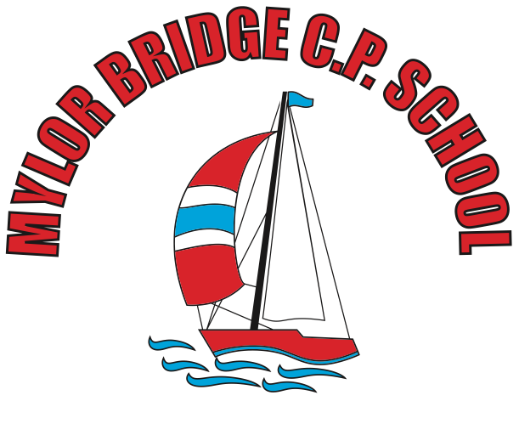

September 2019

Objectives and Aims
At Mylor Bridge School, we follow the objectives of the National Curriculum. Our statement for intent can be found in the coordinator file as well as on the school website. The framework for the 2014 National Curriculum aims to:
Resources
Teachers use a variety of resources, both interactive and physical, to support our learners. Teachers can use Testbase for assessment style questions that can inform our pop quizzes (see assessment) as well as physical apparatus that will help children to conduct experiments and foster scientific curiosity.
Teaching and Learning Style
Teachers will aim to provide stimulating and engaging lessons that encourage a variety of different skills to enable the opportunity for all children to work at the best of their ability. The lessons will, when appropriate, provide a ‘real-life’ feel and apply the skills and knowledge to relevant everyday activities. We provide these opportunities by:
- Encouraging children to use scientific language in discussions
- Setting open-ended tasks that allow children to channel their scientific curiosity through experimentation
- Using a range of resources
- Using TAs and other adults to support children who may be finding the activities difficult or challenging
Planning
Using the 2014 National Curriculum objectives, teachers plan for the short-term, medium-term and long-term. Our planning is supported by the Essentials Curriculum and allows us to take advantage of our locality to support and engage our learners. Due to the nature of the Science curriculum, teachers ensure that skills are built on and developed, allowing consistency in approach to teaching and learning in our school.
Assessment
Each class teacher is going to create a ‘pop quiz’ at the end of each unit to see if the children have understood the objectives taught. This is coupled with observations from the class teacher in lessons and as well as scrutinising work in books. At the end of each unit, each class teacher is going to prepare an assessment experiment lesson where the children will have the opportunity to work scientifically (both individually and collaboratively). These are designed to allow the children to explain, demonstrate and/or describe what is taking place. Key questions are prepared by the teacher to encourage scientific vocabulary when the children are answering. This oral response may be recorded in written form, recorded with audio devices or scribed by adults in order to show evidence.
Children with SEN
At Mylor Bridge School, we teach Science to children of all abilities and needs. Science is a crucial part of our curriculum and helps provide a broad and balanced curriculum for our children. We use a mixture of TA support, mixed ability working groups and open ended activities to allow children with SEN to get the most out of their primary Science education.
Monitoring
As part of the Science coordinator’s role, they are responsible for monitoring the successes in our teaching and learning and supporting colleagues in the teaching of Science across the school. This could be providing opportunities for CPD (continuing professional development), informing and updating colleagues about upcoming changes to Science and provide a direction for the subject as we move forward.

