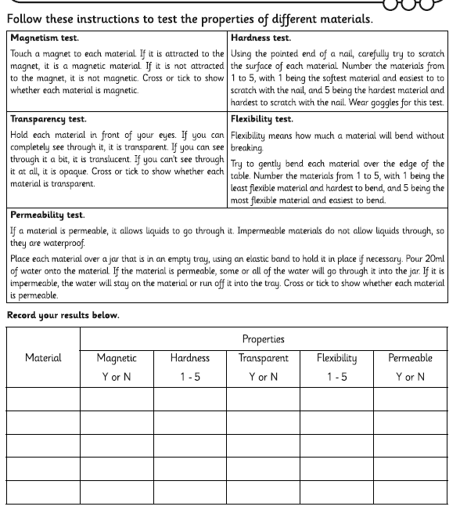

**WALT use testing to understand the properties of materials**

You will need the materials that you collected earlier including a magnet and a nail or something sharp.

Follow the instructions below to test each material for its properties and record the appropriate number for hardness and flexibility; or a yes or no to answer if it is transparent, magnetic or permeable.