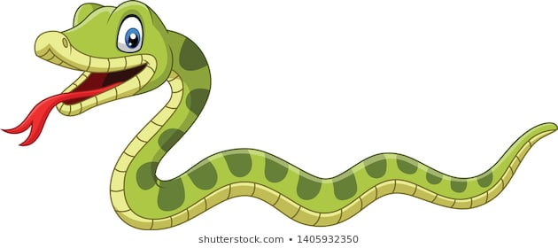
When I finally came around for good, there was nothing weird about my surroundings, except that they were nicer than I was used to. I was sitting in a deck chair on a huge porch, gazing across a meadow at green hills in the distance. The breeze smelled like strawberries. There was a blanket over my legs, a pillow behind my neck. All that was great, but my mouth felt like a scorpion had been using it for a nest. My tongue was dry and nasty and every one of my teeth hurt.
On the table next to me was a tall drink. It looked like iced apple juice, with a green straw and a paper parasol stuck through a maraschino cherry. My hand was so weak I almost dropped the glass once I got my fingers around it. "Careful," a familiar voice said.
Grover was leaning against the porch railing, looking like he hadn't slept in a week. Under one arm, he cradled a shoe box. He was wearing blue jeans, Converse hi-tops and a bright orange T-shirt that said CAMP HALF-BLOOD. Just plain old Grover, Not the goat boy. So maybe I'd had a nightmare. Maybe my mom was okay. We were still on vacation, and we'd stopped here at this big house for some reason. And ..."You saved my life," Grover said. "I... well, the least I could do ... I went back to the hill. I thought you might want this."
Reverently, he placed the shoe box in my lap.
Inside was a black-and-white bull's horn, the base jagged from being broken off, the tip splattered with dried blood. It hadn't been a nightmare. "The Minotaur," I said.
"Urn, Percy, it isn't a good idea—"
"That's what they call him in the Greek myths, isn't it?" I demanded. "The Minotaur. Half man, half bull."
Grover shifted uncomfortably. "You've been out for two days. How much do you remember?"
WALT use the text to answer questions accurately.

- Even though there was nothing strange about Percy’s surroundings, what did he notice about them?
- How did Percy describe the breeze?
- What do you think Percy meant by ‘My mouth felt like a scorpion had been using it for a nest’?
- What did Grover first say to Percy when he saw him?
- What did the black and white bull’s horn that was in the box belong to?
- Can you find a word in the last 6 lines that is similar in meaning to awkwardly?
- Why do you think that it looked like Grover hadn’t slept in a week?
- Can you order these parts of the story so they are in a chronological order?
A – Percy was handed a shoe box B - Percy was gazing on a chair in to a meadow of green fields. C Percy noticed a tall drink on to the table next to him.
- Can you try to summarise this paragraph in less that 50 words?

