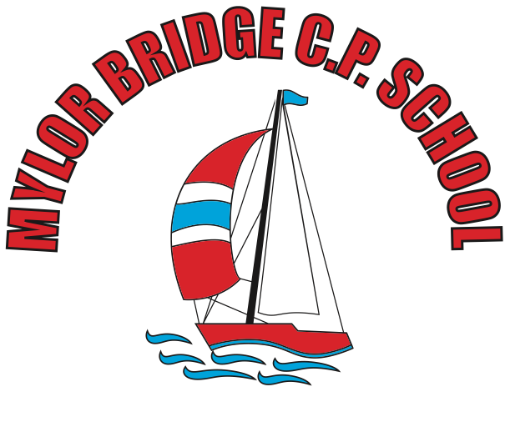
Summer Learning Projects Years 3 & 4 Theme: Around the World
English | Reading Task - Visit Story Nory and let your child choose a story from around the world to listen to. Can they summarise the main events by drawing a comic strip?  Writing Task - Discuss a holiday that your child has been on or a place they’ve visited. Get them to design a postcard and write about what they did there.
Maths | Maths - Ask your child to think about the products that they use at home and how far these have travelled. Food, clothing, toys and electrical items often carry ‘Made in…’ labels. Calculate distances travelled and order from those made closest to home to those made furthest away.
Topic | The project this week aims to provide opportunities for your child to learn more about countries and cities around the world. Learning may focus on different cultures and traditions, famous landmarks, food and clothing.  Virtual Explorer - What are the continents of the world? Where are they located? What languages are spoken in these continents? Ask your child to use Google Maps to explore a continent of their choice. Can they create a continent fact file or choose a particular country they are interested in and create an information guide including the weather, tourist locations, landmarks, weather, traditional music, food, flags.  Mask Making - Ask your child to use paper or cardboard and a range of materials around the home to design and create their  own African mask. Can they find out their importance to African culture by watching this clip?  Dance Around the World - Use SafeYoutube to dance along to some different cultural dances from around the world, such as the  Brazilian Samba, the traditional Diwali stick dance or the Spanish Flamenco. Your child can design a cultural costume for their favourite dance and label it with suitable materials. Upload it to our school website.  Speak the Language - Encourage your child to discuss with their family the links they and their family have to the wider world. Find out places family members have visited on holiday, work/business links or simply countries they would like to visit in the future. Have a go at learning some simple phrases in different languages from around the world and write the phrases using the colours of the flag for that country. You could visit the Mrs Mandarin website here.  Tribal Traditions - Ask your child to find out about the cultural differences, customs and traditions of an indigenous group/tribe from around the world such as the Maori people, Native Americans, the Yanomami tribe or the African Maasai tribe. Ask your child, why it is important indigious people are remembered? Can your child create some artwork inspired by one of the tribes?

