Can you solve two step problems involving multiplication? (GREEN)

- Hats : £28 Sunglasses : £26

How much would it cost to buy 15 hats and 18 pairs of sunglasses?
- Oranges : 32p Apples : 29p

How much does it cost to buy 18 apples and 7 apples?

- Hotel Room : £56 Parking : £22

How much will it cost for me to stay in the hotel for 14 nights if I need to park my car each night?

- Television : £97 Mobile Phone: £34

The shop sells 8 televisions and 22 mobile phones during the day. How much money has the shop made?

- Chocolate : 32p Lolly : 26p

I buy 16 chocolate bars and 9 lollies. How much money will I have left from £10.00?

- Trainers : £44 Football Top : £33

The shop sells 28 pairs of trainers and 17 football tops. How much money has the shop made in total?

- The school is having a charity event. The target is to raise £632. 32 children have each raised £17 each. How much more money is needed before they reach the target?

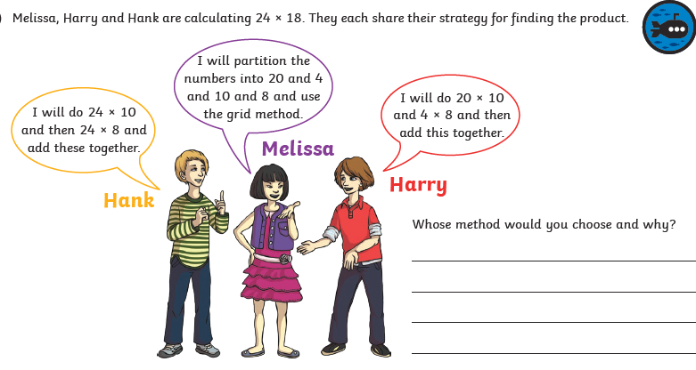

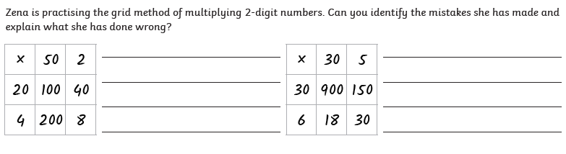

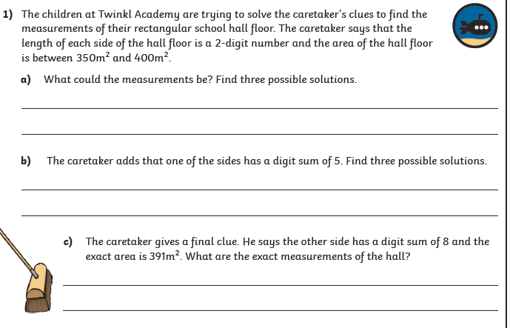
Extension

