Maths Challenge 28.01.21
WALT use our reasoning and problem solving skills
1.
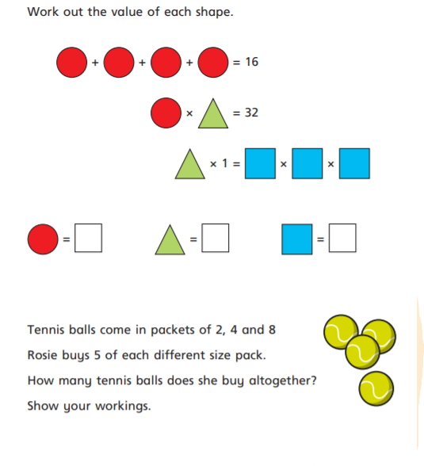
2.

