Maths Challenge 26.01.21

C:\Users\jthomas\AppData\Local\Temp\2497505f-a7ce-4f77-922e-243f49271025.png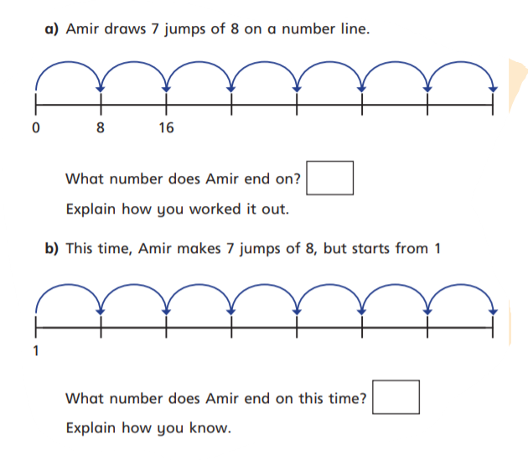WALT use our reasoning and problem solving skills

