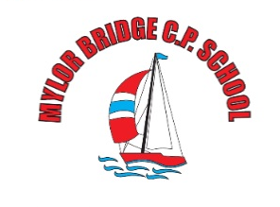
Weekly
Newsletter
email:secretary@mylor-bridge.cornwall.sch.uk

Monday 4th July 2022
Dear Parents/ Carers,

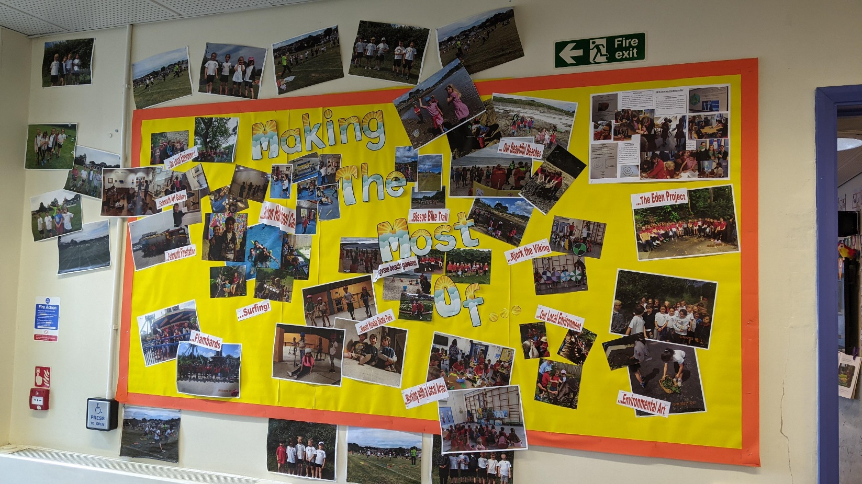
Making the Most of… Month
As we come to the end of our Making the Most of …. Month – we wanted to share with you some of the highlights of the activities which the children have enjoyed. Thank you so much for your help and support of these events. The children have had some super experiences – perhaps you may be able to repeat some of these over the summer holidays to see what your children have enjoyed the most.

Wrap Around Care
As you know, we are working on a wraparound care offer – I am awaiting confirmation from an outside agency regarding this offer. I will be in touch as soon as I hear anything more.

Clubs this half term
All teacher-led clubs have now finished for the year.
Mrs Hamilton/ Mr Wilcox intervention will continue until the last week of term (Last day for interventions Thursday 20th July)
Yoga with Kate Ashbarry – continues next week (not this week due to , see Kate for details

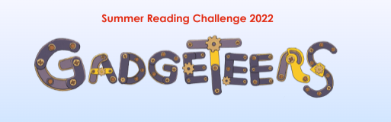
Summer Reading Challenge
We will be hearing all about the summer reading challenge in assembly on WEDNESDAY. See
https://summerreadingchallenge.org.uk/ for further details
E-books are available on line, whilst books to borrow are available from local libraries inc. Falmouth library (details below)
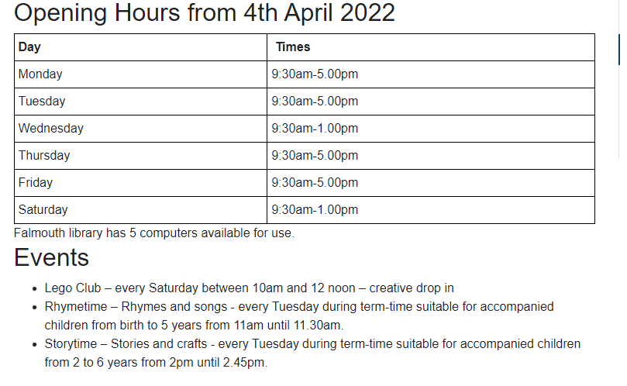
Learning Support
Each week we will be sharing with you some useful resources and websites which support learning here at school.
Last time we looked at Reading. This week, our focus is PE
For ideas and ways of engaging your child in some extra-enjoyable Reading at home, why not try:

Need some ideas to get your child moving: https://www.nhs.uk/healthier-families/activities/10-minute-shake-up/
An in-school favourite: https://www.youtube.com/user/CosmicKidsYoga/videos
60 second sports challenges to download: https://www.youthsporttrust.org/resources/coronavirus-support/60-second-physical-activity-challenges

A few reminders …

Class teachers for Next Year
We have finalised the details for next year’s classes - please see below:

Class 1 | Mrs Mogridge (M-W) Mrs French (Th-F)
Class 2 | Mr Shainberg
Class 3 | Mrs Wood (M-W) Mrs Sanderson (Th-F)
Class 4 | Mrs Thomas (M-W) Mrs Medlin (Thu-F)
Class 5 | Mr Martin
Class 6 | Mr Collinge

Text Messages from School - eSchools App
We have noticed that a few families are not receiving text message alerts. After much investigation, it appears that there is an updated version of the eSchools app – please can you ensure that you have updated the app in order to receive important messages. Thank you

School Starting times from September
Due to the government’s commitment that all schools need to offer 32.5 hrs access time each week. School will start at 8:45 am from 6th September 2022. Children can enter the main playground from the side gate at the time. This is a slight change to the opening of the gates at 8:45 am and children arriving until 9am as is the present practise. Please can parents use this half term to practise the new routine of getting to school for 8:45am – this will be statutory from September. Thank you for your help with this.

Leavers’ Assembly
We would like to invite the family of our Y6 Leavers to a Leavers’ Assembly on Friday 22nd July @ 2 pm – to be held outside if the weather is kind to us – alternatively, we will gather in the hall.

PE uniform – from Sept 22
Just a reminder about PE kit for next year:
We will continue to wear PE kit to school on PE days. PE kit from next September will be: black shorts/tracksuit bottoms/ plain black or navy leggings, a plain white T-shirt (logoed if you wish), either a school jumper/ cardigan or a new PE hoody (now available from Trophy Textiles). Please note Year 6 can use their leavers’ hoodies for their PE kit. These changes will be in place from Sept ‘22.

Making the Most of … Month
The timetable for the remaining Making the Most of … Month is
Class 1 | Class 2 | Class 3 | Class 4 | Class 5 | Class 6
Local Nature Walk  Art Builders project – in class | Fun and Games @ Mylor Playing Field  Design and Build Project – in class. | Cooking in class  Friday 8th July |  | Surfing 7th Thursday July  Children will need wetsuits/towels/swimming costumes  Parents desperately needed to help with transport please | Surfing 7th Thursday July  Children will need wetsuits/towels/swimming costumes  Parents desperately needed to help with transport please

Have a great week
Vicky Sanderson

Dates for your Diaries
22/7/22 – Last day of term Leaver’s Assembly 2:00 pm 3.15pm finish

INSET Dates for 2021-2022

Monday 25th July 2022 – INSET Day
Tuesday 26th July 2022 (additional Jubilee Bank Holiday for Mylor Bridge CP School)

INSET Dates for 2022-2023 are on the school website calendar.

Return to School
Years 1-6 - Tuesday 6th September at 8:45 am
Reception – from 12th September – see induction letters for details

News from Outside Agencies:

Free Under 5s Music Workshop
Please see attached poster regarding a free U5s workshop @ Falmouth’s Princess Pavilions

Cornwall AONB
On Saturday 16 July and Sunday 17 July, free drop-in creative workshops will be taking place in the woods along the self-guided trail. From creative writing inspired by nature, observational drawing for all levels and forest school activities there is plenty for all the family to enjoy on their walk. See Celebrating our Protected Landscape — The Cornwall Area of Outstanding Natural Beauty (cornwall-aonb.gov.uk)

Family Adventure Trail
Please see attached for information from Falmouth International Arts Festival: Immersive interactive family walking trail, Saturday 9 July, Falmouth, 11am–4pm

