24.02.21
WAL T use our reasoning and problem solving skills
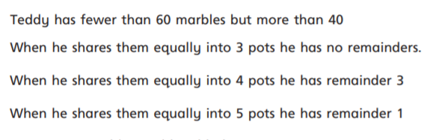
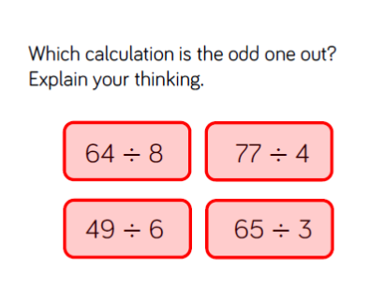
Q1
Q2
Answers

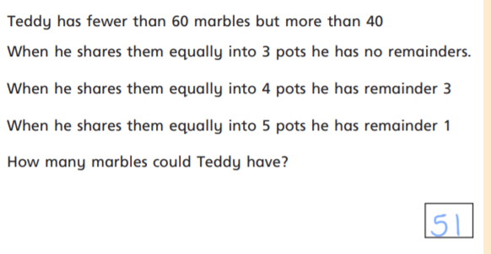
64 divided by 8 is the odd one out as here there is no remainder. I know that 64 is in my 8 times tables. In other words 64 is a multiple of 8.

