9.02.21
WALT use our reasoning and problem solving skills
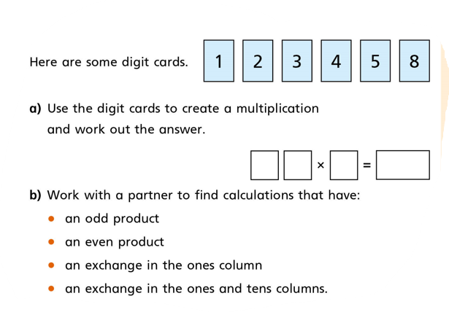
1.

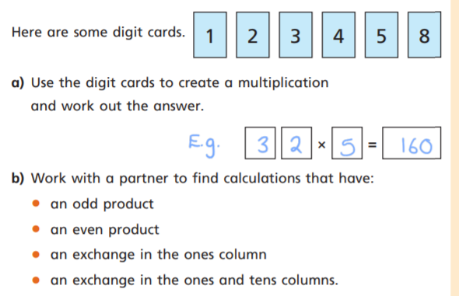

- This answer would be an even product as it ends in 0

- An odd product could be 23 x 5 = 115

- An exchange in the ones column could be 45 x 3 because 5 x 3= 15 so you have to exchange the ten ones for one ten.

- An exchange in the ones and tens columns could be
54 x 3 = 162. I chose these digits because they’re larger numbers.

