French at Mylor Bridge School
Intent
The teaching of languages offers children the opportunity to consider and learn about different cultures. At Mylor Bridge School, we teach French to our children to ensure they make progress in one language and to maximise their outcomes. Our lessons aim to allow the children to read, speak, listen and write in French, as well as providing them opportunities to communicate with one another.
At Mylor Bridge School, we intend to:
- Teach French on a weekly basis
- Foster an interest in learning a language
- Offer the children opportunities to consider cultural similarities and differences
- Provide opportunities for the children to read, write, speak and listen in French
- Support our children to be confident in using their knowledge and understanding of French
Implementation
In Key Stage 2, we teach weekly French lessons from the agreed Twinkl scheme. We focus on providing children with key vocabulary and building on existing words and phrases while applying them to interesting topics. Key vocabulary is explicitly taught and recapped at the start of each lesson as seen below:
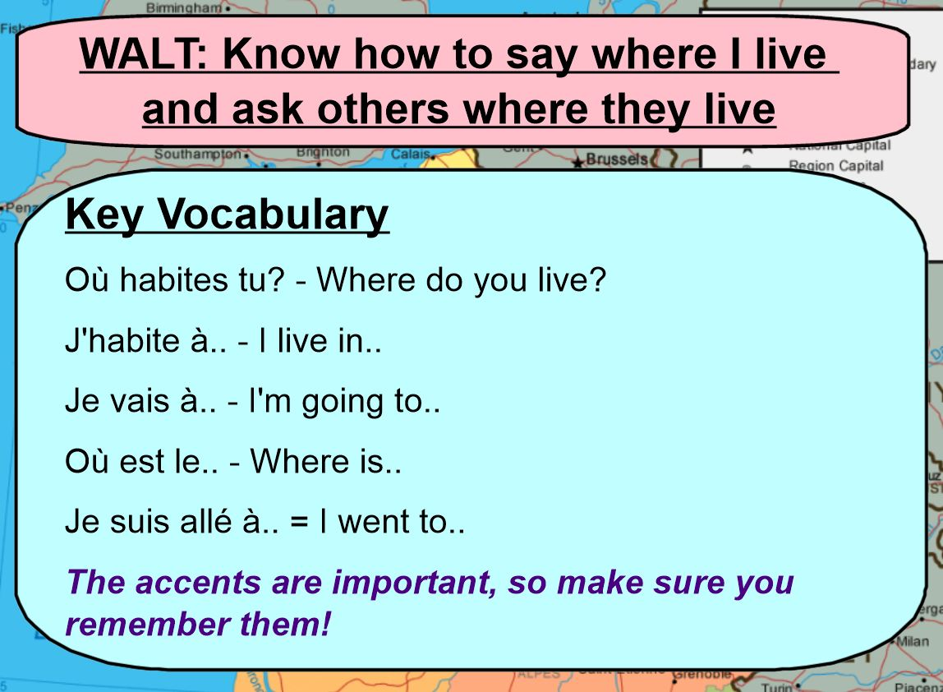
During our lessons, children are offered the opportunity to learn in a variety of different ways. We used songs, games and group activities. As they become more confident, the children can record their progress in the form of sentences.
The children are also set up with Duolingo accounts for them to continue and advance their learning from home.
Impact
By ensuring the measures above are implemented, the children will all develop key language skills outlined in the aims of the National Curriculum, which are:
- understand and respond to spoken and written language from a variety of authentic
sources
- speak with increasing confidence, fluency and spontaneity, finding ways of
communicating what they want to say, including through discussion and asking
questions, and continually improving the accuracy of their pronunciation and intonation
- can write at varying length, for different purposes and audiences, using the variety of
grammatical structures that they have learnt
- discover and develop an appreciation of a range of writing in the language studied.
We will assess the children’s progress by considering the success criteria (seen below) for each unit before making a final teacher summative assessment.
