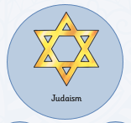
Knowledge Organiser: Judaism
Key facts
- Judaism was founded in 1812 BC when God spoke to Abraham. Abraham was 100 when he had his first child – Isaac.
- People who follow Judaism are called Jews
- The Jewish symbol in the Star of David
- The Jewish holy book is called the Torah and is made up of the first 5 books of the Christian Bible.
- The Jewish vicar is called a Rabbi
- For several hundred years, the Jews are kept as slaves in Egypt. Moses, a Jewish man leads his people out Egypt to Canaan known as the Exodus.
- Jews worship in synagogues
- Some Jewish festivals include: Passover Rosh Hashanah, Yom Kippur and Hanukkah
Key Vocabulary
Judaism, Israel, Abraham, God, Jewish, Jew, religion. Torah, commandments, Moses, Mount Sina, Jerusalem, Rabbi, Torah, scrolls, Hebrew, Yad, Bar Mitzvah, Bat Mitzvah, synagogue. Shabbat/Sabbath, Passover, Rosh Hashanah, Yom Kippur, Hanukkah
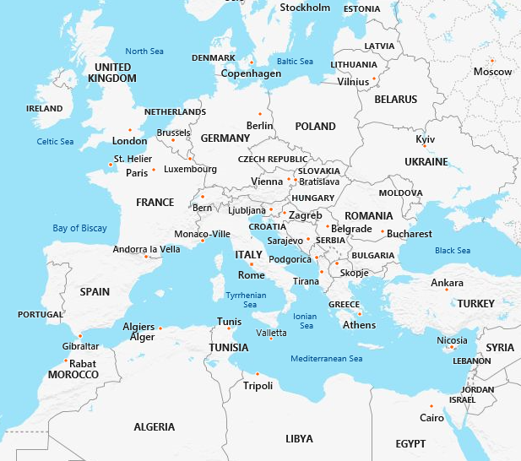
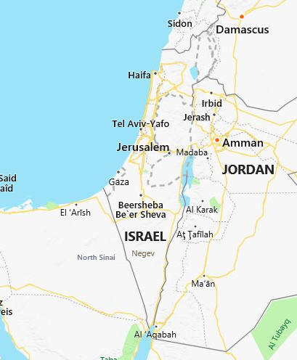
Jewish People have 10 main beliefs (The Ten Commandments)
