**RE Knowledge Organiser – Why do the Hindus want to be good?**

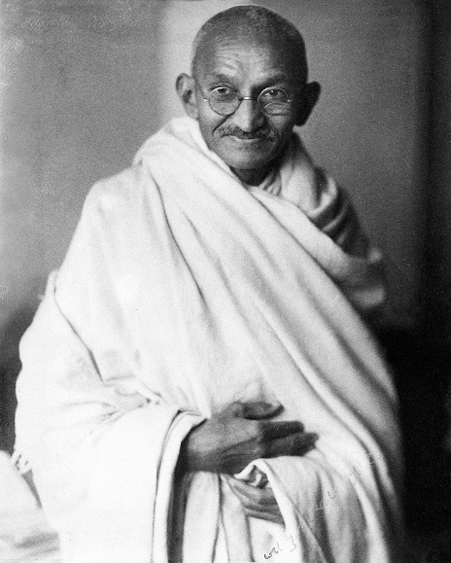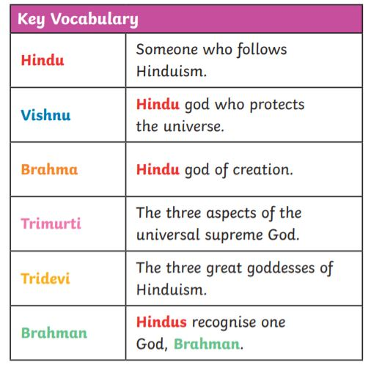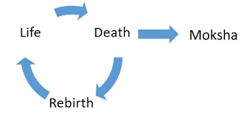

**Key skills for this unit..**

* Considering different perspectives and points of view
* Consider the teachings of leaders in Hinduism
* Appreciate the beliefs and behaviours of Hindus and why they follow certain rituals and the impacts of their beliefs
* Make connections between different teachings

Our key question for this unit is asking why do Hindus want to be good. We will look into how Hinduism came to be, what being a Hindu entails and some of the crucial teachings of this religion.

**Dharma** – In Hinduism it means 'duty', 'virtue', 'morality', even 'religion' and it refers to the power which upholds the universe and society

**Karma** – karma is a concept of Hinduism which explains through a system where beneficial effects are derived from past beneficial actions and harmful effects from past harmful actions, creating a system of actions and reactions throughout a soul's (Atman's) reincarnated lives forming a cycle of rebirth.

**Samsara** – the process of reincarnation

**Moksha** – end of the death and reincarnation cycle