Science – Year 1 Autumn 21
Knowledge Organiser: Everyday Materials
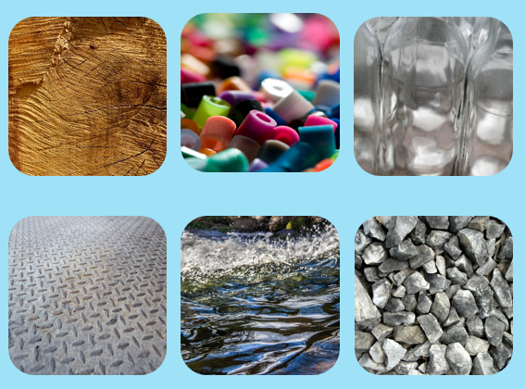

Key Words
Key question 1 | Materials, wood, plastic, glass, metal, water, rock.
Key question 2/3 | Object, common, same.  Describe, properties, hard, soft, stretchy, stiff, shiny, dull, rough, smooth, bendy, not bendy, waterproof, not waterproof, absorbent, not absorbent, opaque, transparent.
Key question 4 | Behave, test, record.
Key question 5/6 | Investigation, prediction, predict, watch, test, record, sensible, results, decision, sort, group, compare.

Properties of materials
Key Questions:
- What different materials are there?
- What is the difference between an object and the materials it is made from?
- What are the properties of everyday materials?
- Which materials have certain properties?
- Which material would be suitable to make an umbrella from?
- Can you sort objects by their properties?

