**TASK 1**

First, try to match the Definitions with the property words in the table.

Now, think about the objects that you have found around your house. Look at the properties below. Do you think that you can compare your objects to the properties?

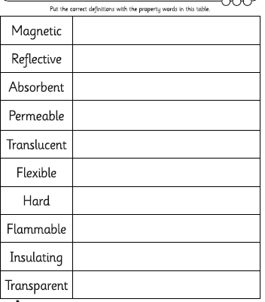

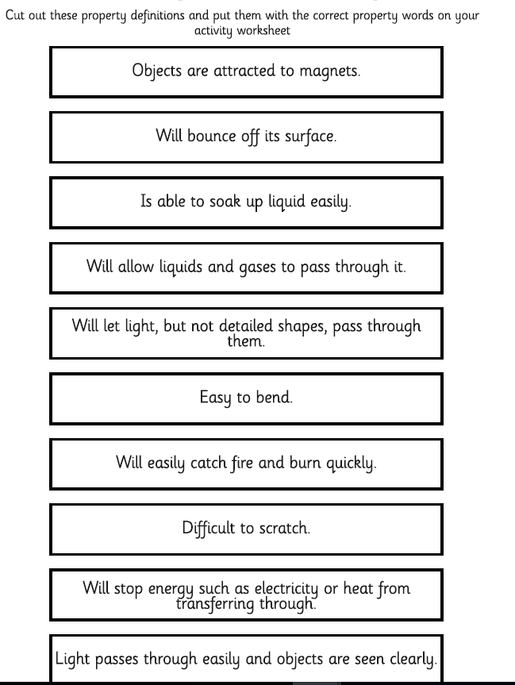

Cut out or copy in these properties definitions and out them with the correct property words above