WALT understand how to find the perimeter of rectangles. 08/01/20
 | Need to think | Conjecture: Doubling the width and doubling the height will always give me the perimeter.

Have a go… Highlight the perimeter fence.

What should be the rules of creating a perimeter fence?

100cm  50cm | Which part is the perimeter, the red part or the blue part?
 | Can you show how to find the perimeter of this rectangle?

Moving on…Use your 12 lines (sticks if in school) only to create different perimeters of shapes. 1 line = 1 metre
Can you label the sides of your shape with your measurements?
Example | Another
One No One Thought Of… | Non - Example
Show your working to solve these:
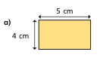
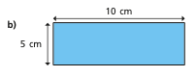
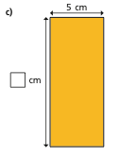
d)  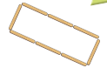 | If each lolly stick is 8cm, what is the perimeter?

