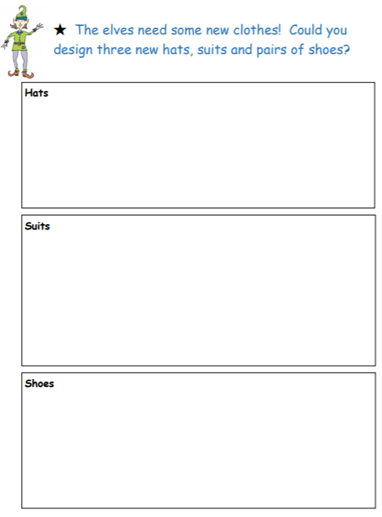

Now pick your favourite design from each box and write some sentences to describe them.