***Ancient Egypt Knowledge Organiser***

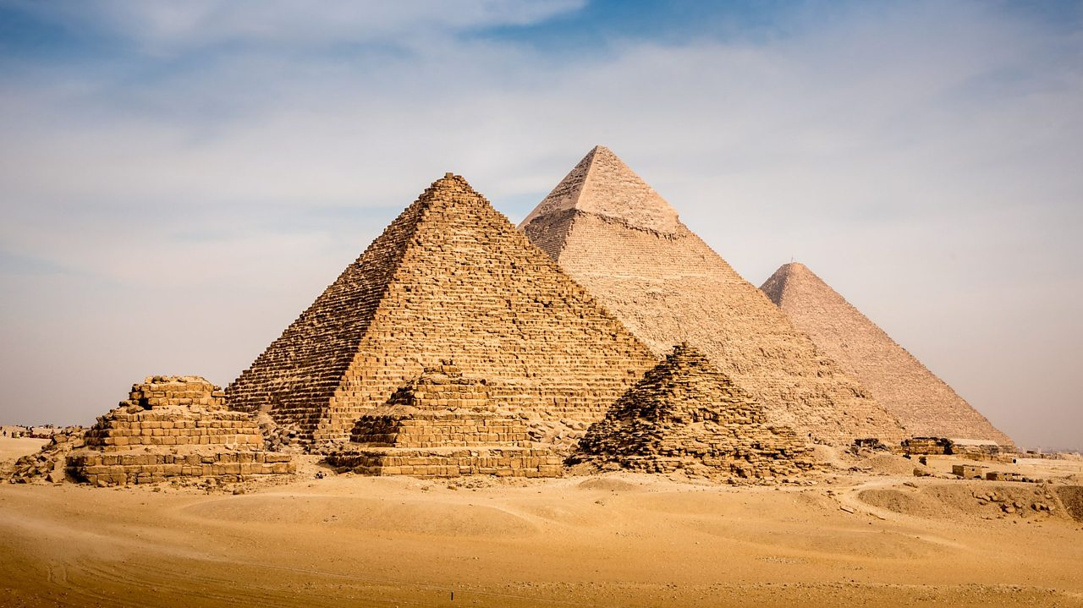

Key Vocabulary

Pharaoh – a ruler in Ancient Egypt

Pyramids – a royal tomb in Ancient Egypt

Nile – the longest river in the world, running through Africa

Mummification – a process to preserve bodies of significant figures

Sphinx – an Egyptian statue depicting the head of a man and the body of a lion

Hieroglyph – pictures used to write something

Cairo – capital of Egypt

Thebes – capital of Ancient Egypt

Key Questions

