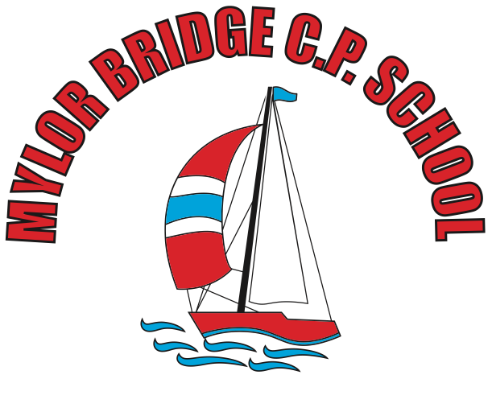
Summer Learning Projects Years 3 & 4 Theme: Food
English | Reading Task - Watch this BBC Bitesize clip on ‘A Healthy Diet’. Ask your child to verbally summarise what they’ve learned.  Writing Task - - Choose a particular food and write an acrostic poem using the food name as a guide for the poem (an acrostic poem is a poem where certain letters in each line spell out a word or phrase). Think about where it comes from? What does it look like? What does it taste like? What is it eaten with? etc.
Maths | Maths – Create a shop of your choice. Label items with a price. Children to practise adding amounts and finding change.
Topic | The project this week aims to provide opportunities for your child to learn more food. Learning may focus on where different foods originate from, what makes a healthy meal, opportunities to cook etc.  Finding Facts about Food- What is a balanced diet? Encourage your child to find out about the different food groups. Make a poster or a PowerPoint about the groups and what a healthy diet is. Here are some videos to support the learning: carbohydrates, protein, dairy and alternatives, fruits and vegetables and fats. As a challenge, your child could investigate where their food comes from. Which foods come from the UK? What would we eat if we could only source food from the UK?  The Great Giuseppe Arcimboldo - Look at the artwork of Giuseppe Arcimboldo. Maybe recreate some of his paintings with real fruit and vegetables. If not, recreate one of his pieces using pencils, crayons or another material of choice. Alternatively, use fruit and vegetables to create some decorative prints e.g. potatoes, cauliflower or carrots. These could be repeated pattern prints. Share the artwork at  Energy and Exercise- Food provides us with energy and we need energy to exercise; exercise keeps us fit. Ask your child to choose a dance from Supermoves. Following this, they can choreograph their own dance. They may want to plan the dance first by sketching ideas for their new routine. Ask them to perform it to the family. Recommendation at least 2 hours of exercise a week.  Planning and Preparation - As a family, design a healthy meal plan for the week. Discuss favourite foods and why they enjoy them? Talk about healthy and unhealthy foods and explain the importance of eating a balanced diet. Why not write the weekly shopping list together and ask your child to categorise each food item? Perhaps you could prepare some meals together? Task your child with measuring and weighing ingredients.  Lunch Around the World - Look at lunch around the world and investigate how people eat in other parts of the world. Can your child locate the countries mentioned on a world map? Ask your child to create a fact file or mini book about their findings.

