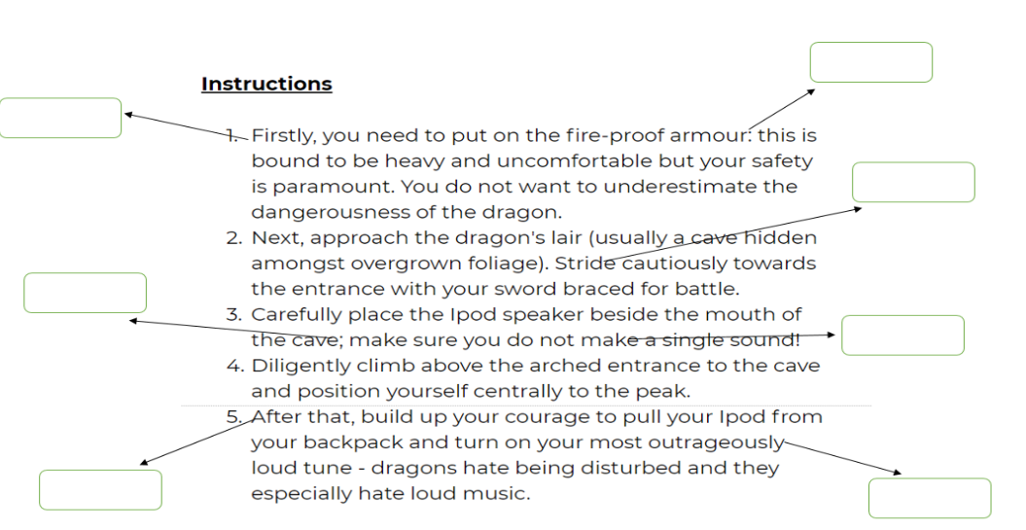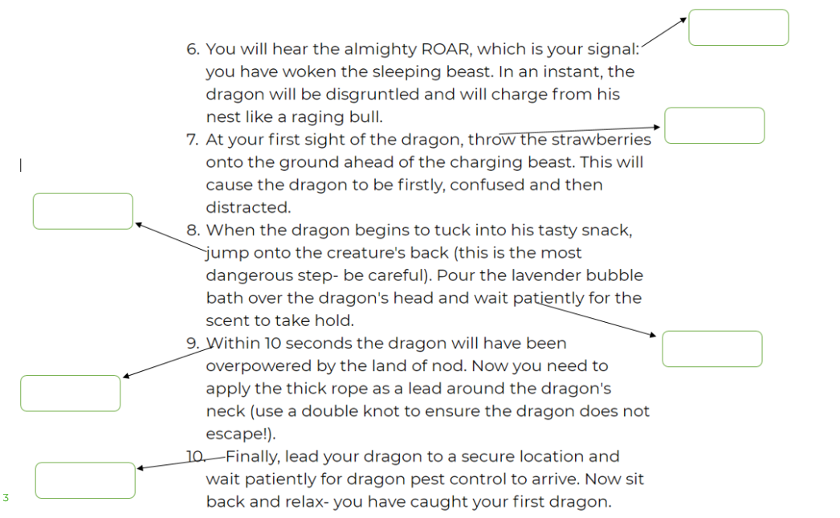

;;

Adverbial, Semi colon Imperative verb Colon

11

13

12

10

1

9

5

8

3

7

6

4

2