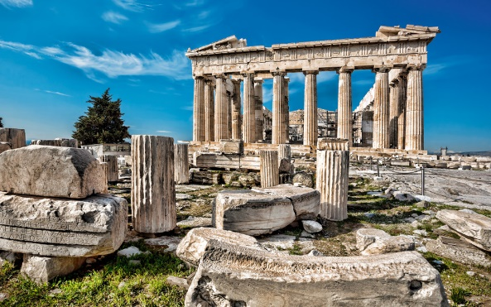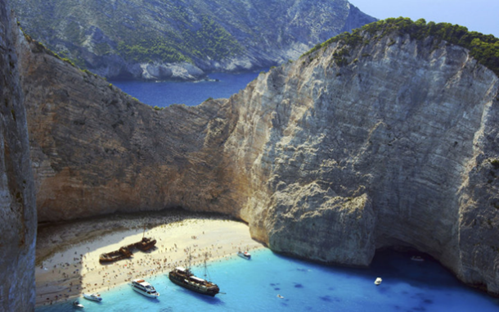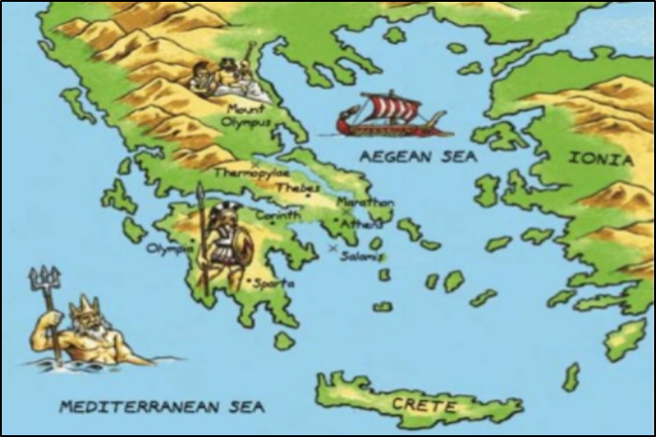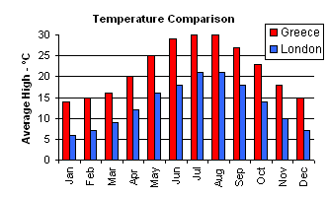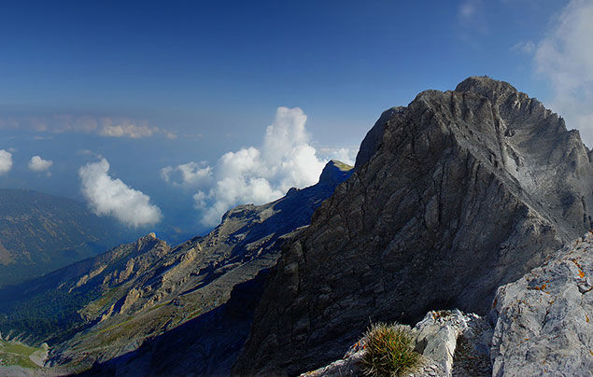

**The timeless beauty of the Parthenon**.

**Crystal clear waters and fine sandy beaches**

**Mount Olympus stands at 2918m above sea level**

**Key Questions**

* How many islands is Greece made up of?
* What is the landscape like in Greece?
* What about the climate? How is the climate different to the climate in the United Kingdom?
* How can we find out about physical and human features of Greece?
* What do Greece Trade?
* What types of food do they eat in Greece?
* What are the four main physical features of Greece and how did these influence Ancient Greek society?
* Why does Greece make a great holiday destination.
* Are there similar countries in Europe to Greece?
* Do you know where the Mediterranean sea, Aegean sea and the Ionian sea is?
* What is the tallest mountain in Greece?

**Ancient Greece Knowledge Organiser - Geography**

Map of Ancient Greece

Greece’s position next to the sea (there are over 1400 islands) meant Ancient Greeks were a seafaring people. Trade between the islands led to the creation of ‘city-states’ (polis). Each city-state was ruled by a powerful city, led by a ruler or (later) government. Greece is a warm country, but winds from the Mediterranean, and rains from the north, kept temperatures livable and created fertile farming conditions.