Natural Disasters – Year 6 Geography Knowledge Organiser
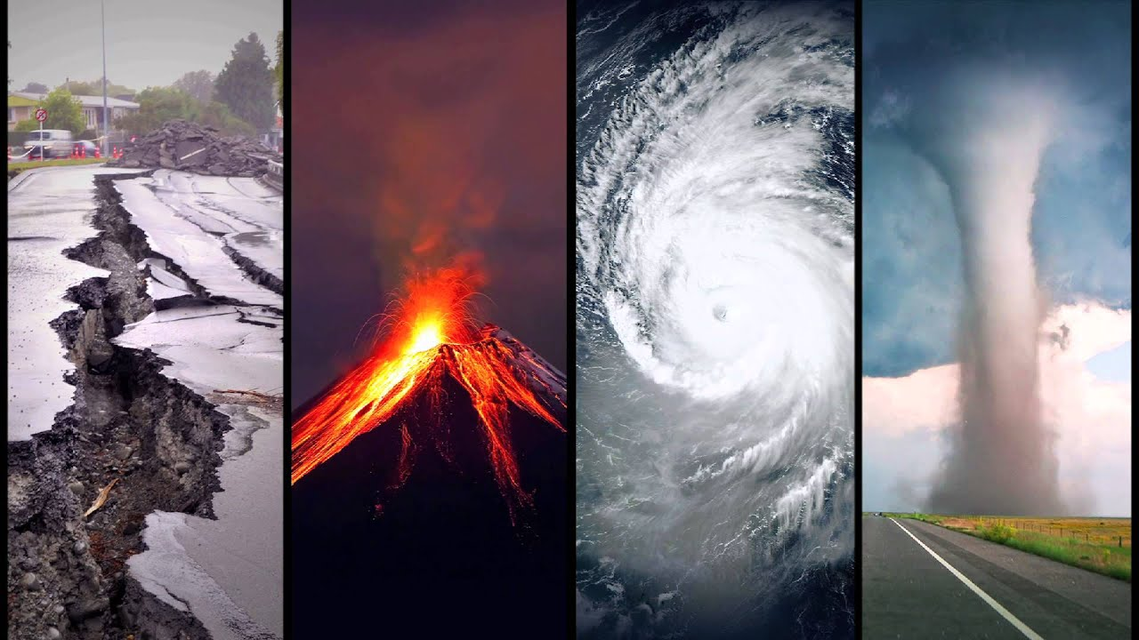
Key Dates/Case Studies
Case studies with a focus on North America – discuss environmental regions.
- Mt. St Helens volcano (1980)
- Yellowstone fires (1988)
- New Orleans/Hurricane Katrina (2005)
- Hurricane Harvey (2017)
- California earthquakes (2019)
- Yellowstone Supervolcano
-
Key Vocabulary
Natural disaster – a natural event (such as a flood, earthquake, volcano etc.) that causes a great deal of damage or loss of life.
Earthquake – a violent shaking of the ground due to a sudden shift of tectonic plates, typically causing great damage.
Tectonic plates – plates of solid rock under the Earth’s surface, under immense pressure.
Volcanic eruption – a violent discharge of steam and volcanic material.
Dormant – in an inactive state (a dormant volcano is one that isn’t erupting)
Flood – an overflow of water above normal levels, especially over what is normally dry land
Hurricane – a storm with a violent wind
Cyclone – a system of winds rotating towards lands
Typhoon – a tropical storm in the region of India or Western Pacific oceans

Key Questions
What is a natural disaster?
What causes natural disasters to occur?
How are the Americans prepared for future disasters? What safety measures have been put in place?
How did a particular natural disaster impact the people who lived there?
What happened before/after the disaster occurred?
Which tectonic plates shifted for the earthquakes in California to happen?
What is the difference between hurricanes, cyclones and typhoons?

