HOW TO TRAP A BABY MOLTEN GOBLIN (AMARE COBALUS)
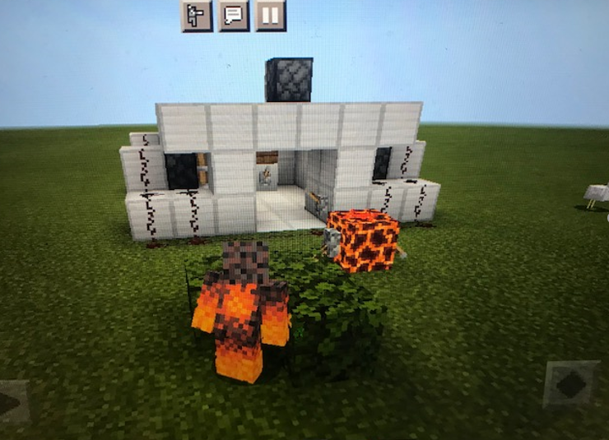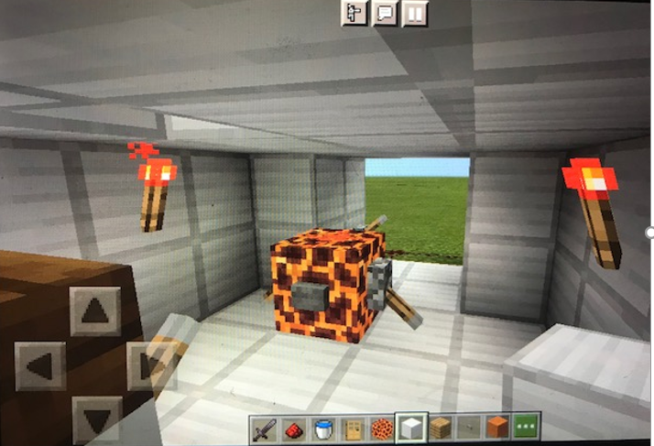
FIRST OF ALL, HIDE BEHIND SOMETHING BIG ENOUGH TO CONCEAL YOURSELF AND WAIT FOR THE GOBLIN TO ENTER.
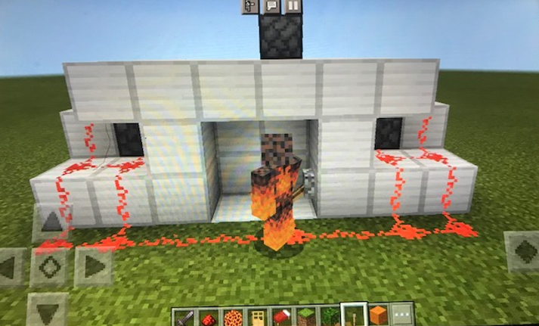
THEN, CLOSE THE DOORS BEHIND IT.
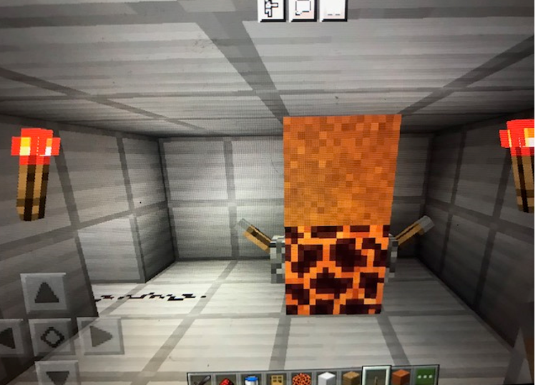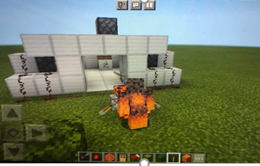
WAIT FOR THE THUD, AND THEN TAKE YOUR GOBLIN OUT OF THE CAGE. THEN CALL THE GOBLIN REMOVAL COMPANY.

