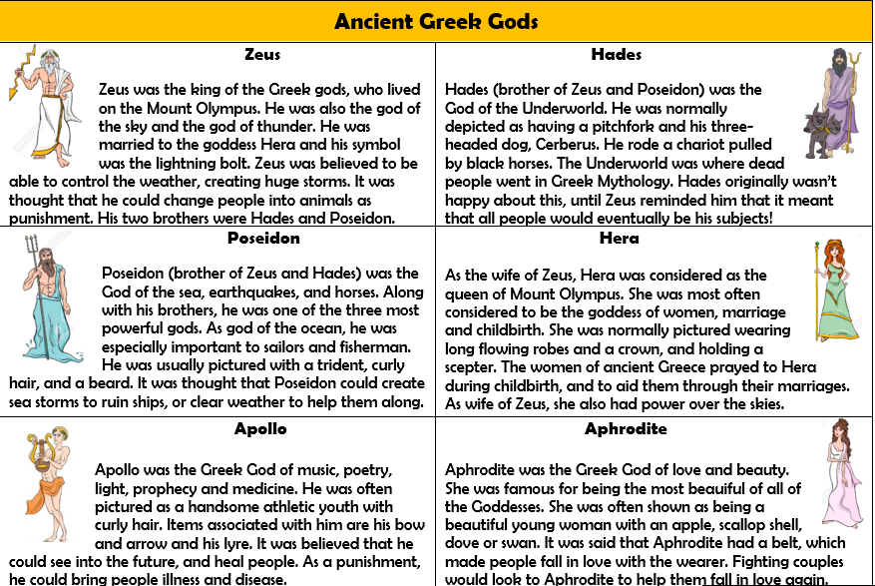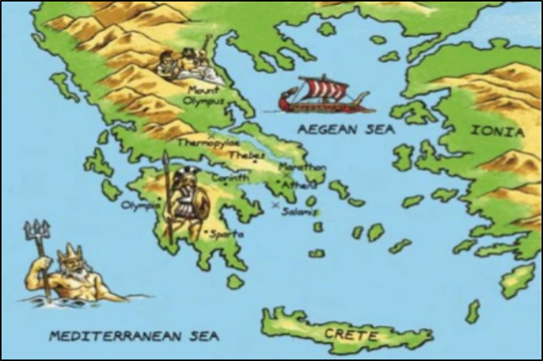

Can you find out about some of these famous people and places in Greece?

* **The Acropolis**
* **The Parthenon**
* **Mount Olympus**
* **Socrates**
* **Aristotle**
* **Alexander the Great**

Map of Ancient Greece

Greece’s position next to the sea (there are over 1400 islands) meant Ancient Greeks were a seafaring people. Trade between the islands led to the creation of ‘city-states’ (polis). Each city-state was ruled by a powerful city, led by a ruler or (later) government. Greece is a warm country, but winds from the Mediterranean, and rains from the north, kept temperatures livable and created fertile farming conditions.

**Key Questions**

1. **What were the major differences between the Athens and Sparten societies?**
2. **What is a Hoplite?**
3. **Why did the battle of Marathon take place?**
4. **Can you name three gods and describe them and what they were in charge of?**
5. **Are these statements true or false?**

* Athenians had a powerful navy.
* Today’s marathon distance is about 219 km.
* Ancient Greeks wanted to please their gods so they gave them sacrifice.
* Cronos ate most of his children.
* Athenians were famous for their skilled archers.
* Theatre performances originally formed part of a religious festival.
* Spartan boys went to a military school at the age of 10.
* Spartans refused to help Athenians as they were engaged in a different war.

1. **What are the main differences between the Ancient Olympics and the Modern ones?**
2. **What influences does the modern world take from the Ancient Greeks?**
3. **What can we look at to learn about the Ancient Greeks?**
4. **Who was the famous messenger that the Greeks sent on a 26 mile mission?**

**Ancient Greece Knowledge Organiser - History**