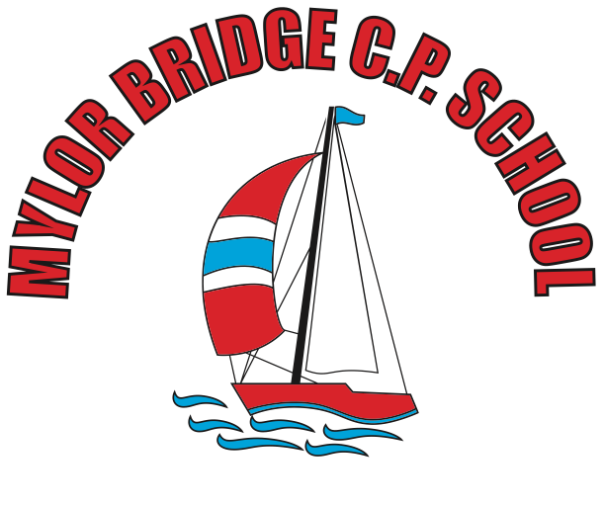
Summer Learning Projects Years 3 & 4 Theme: Underwater
English | Reading Task - Read this extract from Ocean Emporium. Use a dictionary to clarify any unfamiliar vocabulary.  Writing Task - Create an information report about one of the world’s oceans. This could include a map locating the ocean, what plants and animals live there and the impact humans have on it.
Maths | Create a large grid on the floor to represent a map of the ocean, with various hazards included. Then, ask your child to make a paper boat and use directional language (half turn, quarter turn, clockwise, anti-clockwise etc) to navigate their ship safely across the oceans.
Topic | The project this week aims to provide opportunities for your child to learn more about life in and around the sea. Learning may focus on the strange and wonderful creatures and plants that occupy our oceans, their habitats and how human beings affect this environment.  Exploring the Blue Abyss - Can your child remember the oceans of the world? Encourage your child to find out about the five different layers of the ocean (Sunlight Zone, Twilight Zone, Midnight Zone, Lower Midnight Zone or Abyss and the Trenches). Sea creatures adapt incredibly to live in specific layers where the conditions, such as the temperature and light levels, can change. Can your child explore the creatures that are found in each layer of the ocean and create a fact file for each ocean layer with a labelled diagram?  Submarine Sculptures - Ask your child to look at pictures of real submarines for inspiration and create their own model submarine from different materials found at home e.g. plastic bottles, paint, coloured pencils, string, papier-mâché, sweet wrappers, tin foil and cardboard. When your child is collecting materials, question them on the suitability of each material. Alternatively, children could design and create a boat to carry a load on the ocean using junk modelling.  ‘Under the Sea’ Stretches - Ask your child to try some yoga using the Cosmic Kids Youtube channel. There are lots of ‘Under the Sea’themed yoga workouts and even a Moana-themed adventure! Or simply get stretching to some relaxing deep sea sound effects.  Preventing Pollution - Encourage your child to ask different family members what they know about plastic waste (e.g. plastic bags, six-pack rings and microbeads) that ends up in the ocean. They could do this by creating a questionnaire and carrying out interviews (perhaps over Facetime with adult supervision?). Discuss how you could help reduce ocean pollution and work together to create a persuasive poster to reduce plastic waste.  Reef Research - The Great Barrier Reef is the only living thing which is visible from space! Encourage your child to take a virtual tour of the reef using AirPano and create a poster or video to promote the Great Barrier Reef. Ask them to use scientific language relating to the habitats and species groups found in the reef. Can your child identify the main threats to The Great Barrier Reef and include these too?

