Maths Wednesday 15th July
Have a go at the problems below. I’d be interested in hearing how you want about solving them.

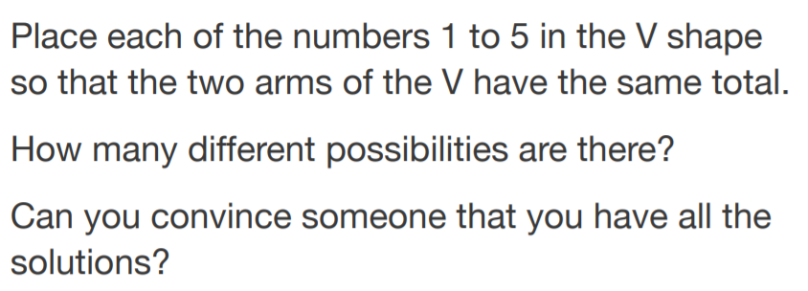
Problem Number One Magic Vs

Problem Number Two – Three Balls
- Two children are playing with three balls, one blue, one red and one green.
- They toss up the balls, which run down a slope so that they land in a row of three.
- In how many different ways could the balls land?
How do you know you have found them all?
- What if there were four coloured ball: Blue, Red, Green and Yellow?

Follow the link below for an interactive version.
https://nrich.maths.org/2858

