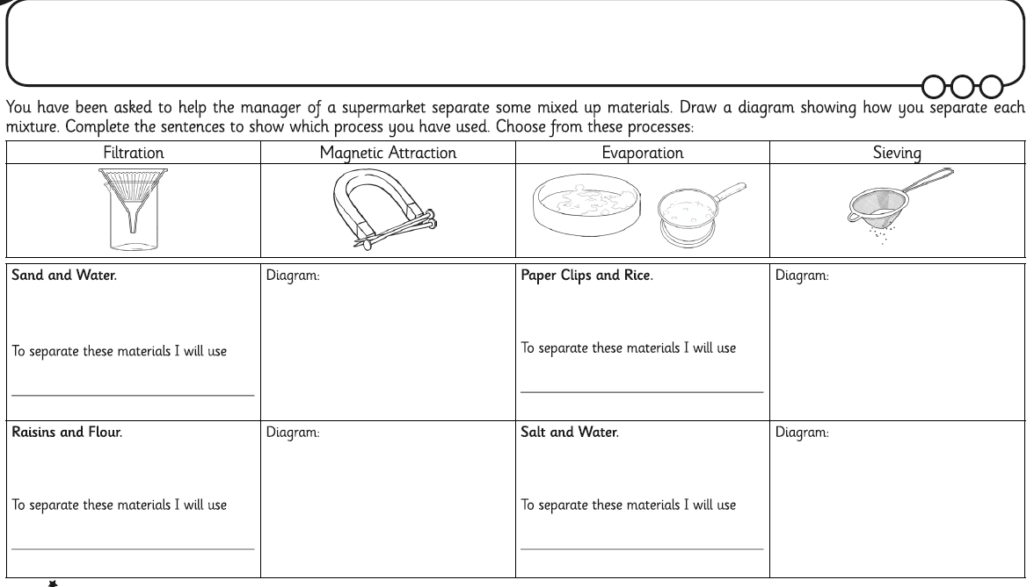

How would you separate the mixture of items below? Draw a diagram to show how you would do it. If you have the materials in your house maybe you could try.