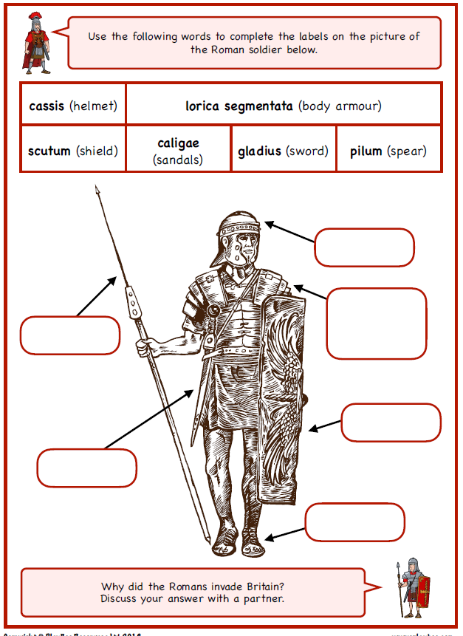
WALT understand why and how the Romans successfully invaded Britain

