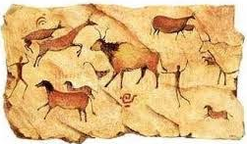
Knowledge Organiser: Stone Age to Iron Age
2019

Chronology – the arrangement of dates or events in the order of which they occurred
BC – Before Christ. A way of dating years before the birth of Jesus. The bigger the number BC, the longer ago in history it was.
Anno Domini – ‘In the Year of Our Lord’. AD is used to show dates after the birth of Jesus. This year is AD 2019.
Archaeology - The study of the buildings, graves, tools and other objects that belonged to people who lived in the past, in order to learn about their culture and society.
Historical Evidence – Anything left over from the past is a source of evidence.
The Stone Age is the name given to the earliest period of human culture when stone tools were first used.
The Bronze Age is the time period when bronze replaced stone as the preferred materials for making tools and weapons.
The Iron Age is the time period when iron became the preferred choice of metal for making tools.
The Stone Age
The period of prehistory in Britain generally refers to the time before written records began. It begins when the earliest hunter-gatherers came to Britain from Europe around 450,000 BC and ends with the invasion of the Romans in AD43,
The Stone Age is often divided into three periods:

- Paleolithic (Old Sone Age)

- Mesolithic (Mid Stone Age)

- Neolithic (New Stone Age)

The Paleolithic era lasted for such a long time that it accounts for 99% of all human history! The evolution of humans from the earliest homonims to Homo Sapiens occurred in this period. Some of the major advances in technology were achieved during this period including the control of fire, agriculture, metalworking and the wheel.

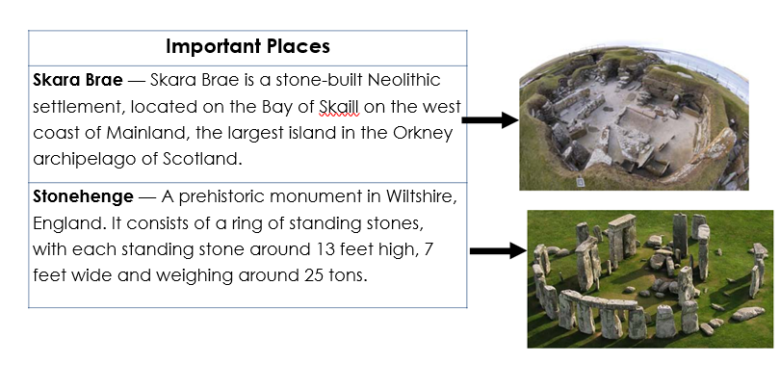

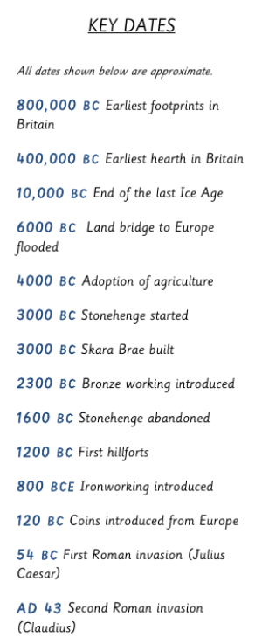

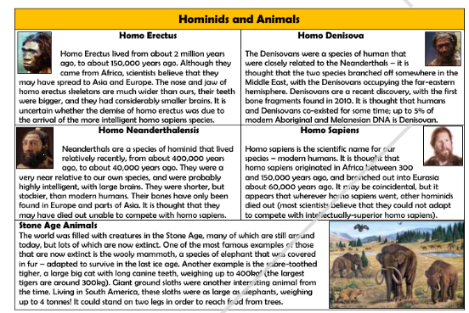

Prehistory History

Stone Age Bronze Age Iron age Romans Saxons

Celts

500,000 | 2,000 | 700 | 43 | 410

BC | The birth of Christ. | AD
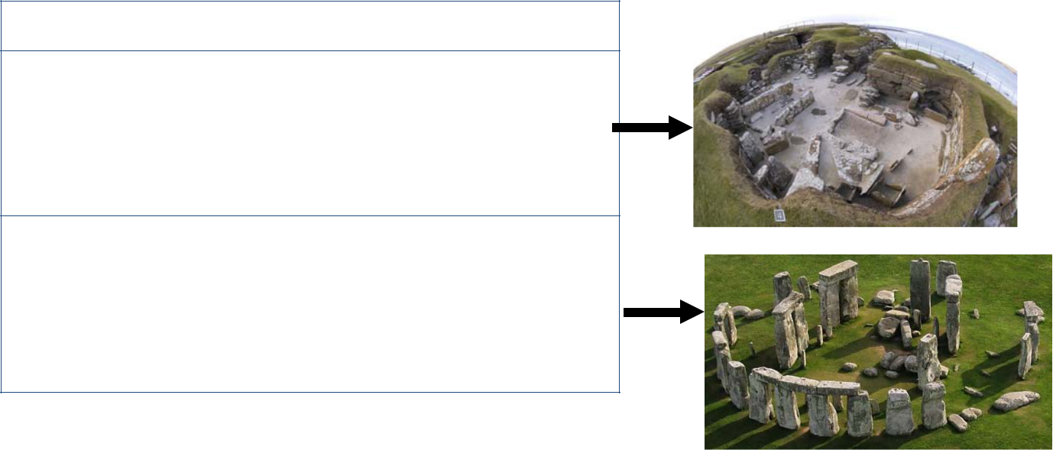

Important Places

Skara Brae — Skara Brae is a stone-built Neolithic settlement, located on the Bay of Skaill on the west coast of Mainland, the largest island in the Orkney archipelago of Scotland.

Stonehenge — A prehistoric monument in Wiltshire, England. It consists of a ring of standing stones, with each standing stone around 13 feet high, 7 feet wide and weighing around 25 tons.

 | Vocabulary
Stone | The stone age is the name given
Age | to the earliest period of human
 | culture when stone tools were
 | first used.
Bronze | The bronze age is the time peri-
Age | od when bronze replaced stone
 | as the preferred materials for
 | making tools and weapons.
Iron Age | The iron age is the time period
 | when iron became the preferred
 | choice of metal for making tools.
Neolithic | The neolithic is the youngest part
 | of the Stone Age. The word
 | "neolithic" comes from two words
 | in Greek: "neo", meaning "new"
 | and "lithic", meaning "stone". The
 | neolithic period is the time when
 | farming was invented and when
 | people started caring for ani-
 | mals, such as cows, sheep and
 | pigs.
Forage | To look widely for nourishment or
 | other provisions.
Thatched | A thatched house or a house
 | with a thatched roof has a roof
 | made of straw or reeds.
Pre- | Prehistoric means the time be-
historic | fore recorded history.
Monu- | A group of huge stones, often set
ment | up in a line or circle.
Tribe | Iron age people who lived in the
 | same area and did similar things.

