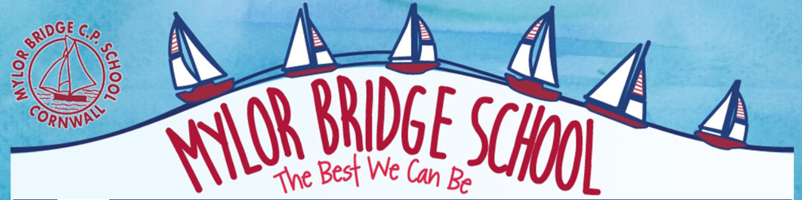

English Curriculum Intent Statement
Aims
The 2014 National Curriculum for English aims to ensure that all children:
- read easily, fluently and with good understanding
- develop the habit of reading widely and often, for both pleasure and information
- acquire a wide vocabulary, an understanding of grammar and knowledge of linguistic conventions for reading, writing and spoken language
- appreciate our rich and varied literary heritage
- write clearly, accurately and coherently, adapting their language and style in and for a range of contexts, purposes and audiences
- use discussion in order to learn; they should be able to elaborate and explain clearly their understanding and ideas
- are competent in the arts of speaking and listening, making formal presentations, demonstrating to others and participating in debate.
Statement of Intent
At Mylor Bridge School, we believe that all children should be the best they can be. The school strives to foster in our pupils: creativity, kindness, confidence, determination and self-awareness. Through the continuous focus of the four Rs (being Resilient, Resourceful, Reflective and building Relationships), our intent is that we have an engaging, high quality English curriculum that is accessible by all children.

Whole School Approach to Teaching Reading
KS1
Intent: early proficient readers as soon as possible. To have a love read of reading and to confidently read a variety of texts with understanding for both pleasure and information.
Implementation:
Teaching the mastery of the basic skills of reading by:
- Daily structured phonics groups using Twinkl Planet; a progressive scheme of work based on Letters and Sounds
- Reading scheme books aligned to Letters and Sounds and phonic phases
- Replenished reading books for children in the Infants matched to phonic phases
- EYFS and KS1 split into 5 groups and taught in vertical groupings daily
- Phonics 1:1 intervention every afternoon to address gaps in phonic knowledge
- Relevant and meaningful opportunities to apply phonics knowledge and reading skills in EYFS and across the curriculum in Years 1 and 2
- Engagement with parents through reading certificates, reading records, tapestry, newsletters, conversations and book reading related events. To trial Reading Cafes when Covid restrictions allow.
- Guidance and clear expectations to parents about reading at home. Also available on the website.
- Embedding a true love of reading with daily opportunities to practise and listen to stories.
- Reading books changed daily. Infrequent home readers identified and addressed through intervention
- High prior attainment children in Y2 to access Accelerated Reader
- Use of VIPERS questioning techniques to develop comprehension skills. All staff and reading helpers use VIPERS sentence stem support card to aid their questioning.

Impact:
- % of pupils working at ARE within each group will be at least in line with national averages
- High % of pupils working at Greater Depth
- 74% EXS in Reading 2019 (% Boys, % Girls) GDS 26%
- improvement from 2018 outcome which was 70%
- 80% passed phonic screening 2019. This is up from 70% in 2018 and the reversal of a 3 year downward trend
- EYFS Reading 80% 2019
There will be no significant gaps in the progress of different groups of pupils

KS2

Intent: To have a love read of reading and to confidently read a variety of texts with understanding for both pleasure and information.

Implementation:

- Daily reading practise to develop good reading habits and stamina in reading
- Regular diary checks by TA’s to help monitor reading and establish good reading habits
- Guidance and clear expectations to parents about reading at home available both on the website and sent home
- The importance of reading highlighted through newsletters, displays, reading events; assemblies, author visits, World Book Day, book fairs, sponsored reads. To trial Reading Cafes when Covid restrictions allow.
- Daily ‘Story Time’, which includes sharing a variety of genres. Opportunities for teachers and TA’s to model good reading.
- VIPERS questioning techniques to develop verbal and written comprehension skills. All staff and reading helpers use VIPERS sentence stem support card to aid their questioning.
- Use of Accelerated Reader to monitor closely the frequency and progress in reading. Weekly AR certificates in assembly. Teachers and TA’s to hear struggling readers daily.
- English lessons – a commitment to using high quality mixed genre texts as a foundation for teaching both reading and writing skills

Impact:

- % of pupils working at ARE within each group will be at least in line with national averages
- High % of pupils working at Greater Depth within each group
- 76% EXS in Reading 2019 (% Boys, % Girls) GDS
- improvement from 2018 outcome which was 70%
-There will be no significant gaps in the progress of different groups of pupils

Whole School Approach to Teaching Writing
KS1
Intent: early proficient writers as soon as possible. Enjoyment and engagement in writing. To be able to write proficiently in a variety of texts styles.
Implementation:
Teaching the mastery of the basic skills of writing by:
- Daily structured phonics groups using Twinkl Planet to embed sounds and spelling patterns including opportunities to practise writing new words and letter formation. Assessment after 6 weeks and groups adjusted accordingly.
- Use of Talk for Writing to imitate story patterns and language patterns. Oral rehearsal before writing, story maps, WAGOLL’s, shared and modelled writing.
- Relevant and meaningful opportunities to apply phonic knowledge, spelling patterns and writing skills in EYFS and across the curriculum in Y1 & 2
- Twinkl spelling programme used from Y1-6. Spellshed used for activities to support children’s learning of spellings.
- Y2 assessment of common exception words in Sept and Dec to advise on intervention groups
- Incorrect letter formation identified and addressed. Joined handwriting introduced in Y1 in line with school’s handwriting scheme.

Impact:
- % of pupils working at ARE within each group will be at least in line with national averages
- High % of pupils working at Greater Depth
- 68% EXS in Writing 2019 (% Boys, % Girls) GDS 16%
EYFS - Writing 70% 2019
There will be no significant gaps in the progress of different groups of pupils

Whole School Approach to Teaching Writing
KS2
Intent: Enjoyment and engagement in writing. To be able to write proficiently in a variety of texts styles.
Implementation:
Teaching the mastery of skills of writing by:
- English lessons – a commitment to using high quality mixed genre text as a foundation for teaching both reading and writing skills

- Use of ‘Talk for Writing’ to imitate story patterns and language patterns. Oral rehearsal before writing, story maps, WAGOLL’s, shared and modelled writing.

- Clear sequence of learning; beginning with an initial assessment ‘Cold Task’ and three distinct phases of Imitation, Innovation and Invention. Children follow clear sequence of learning - ‘Boxing Up’ – draft – proof-read/edit (Purple Polish) and publish (Hot task). Use of Talk Partners to act as both audience and aid to editing /redrafting

- Spellshed spelling programme used from Y3-6. Weekly dedicated lesson to introduce/investigate new spelling pattern/rule. Weekly spelling test including dictation to assess understanding. Online and paper Spellshed activities used to support children’s learning of spellings. Phonics in place for children not making the expected progress.

- Key vocabulary prioritised across the curriculum; supported by the introduction of Knowledge Organisers in Science and foundation subject.

- Opportunities for Writing Across the Curriculum at the end of a Geography/History/Science.

- Established handwriting scheme. Early invention for those struggling with correct letter formation

Impact:
- % of pupils working at ARE within each group will be at least in line with national averages
- High % of pupils working at Greater Depth
- 68% EXS in Writing 2019 (% Boys, % Girls) GDS 16%
There will be no significant gaps in the progress of different groups of pupils

