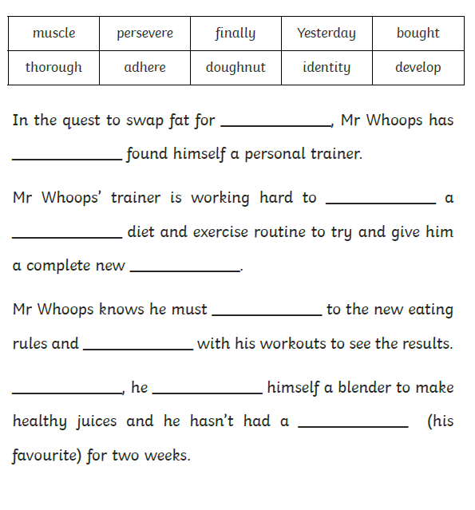

Use the correct spellings to fill the gaps