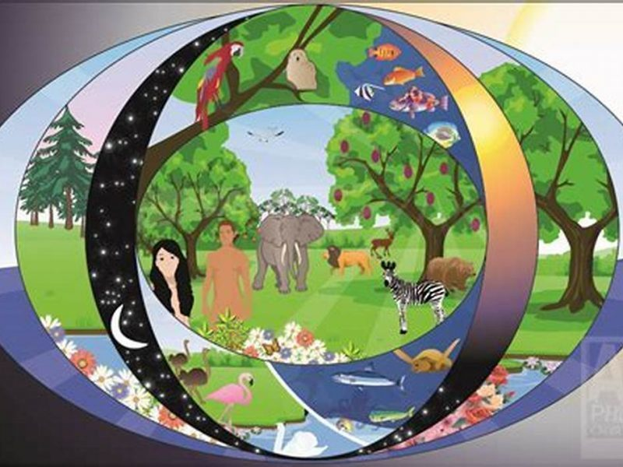**RE Knowledge Organiser – Creation and Science: Conflicting or complementary?**

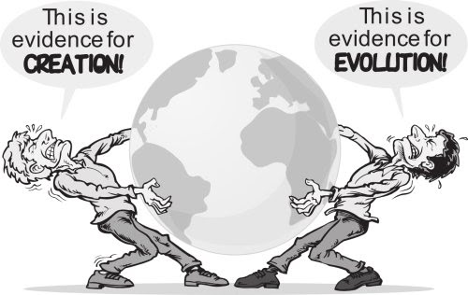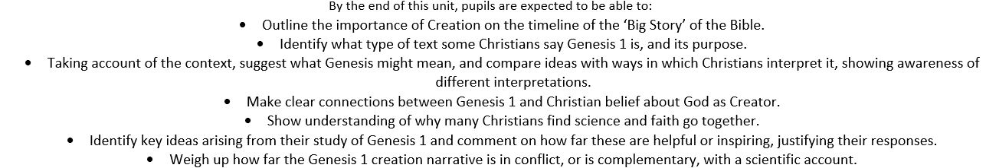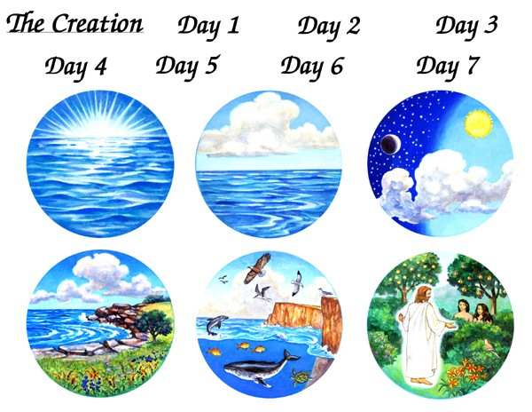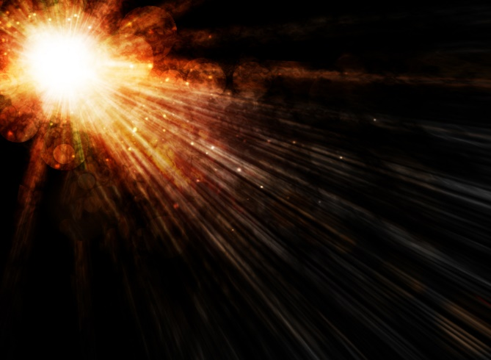

**Key Vocabulary**

Creation – the creation of the universe when regarded as an act of God  
Genesis – the biblical account of the creation of the world  
Christianity – the religion based on the teachings of Jesus Christ   
Conflicting – going against ideas  
Complementary - supporting ideas