25.01.21

WALT use reasoning and problem solving skills

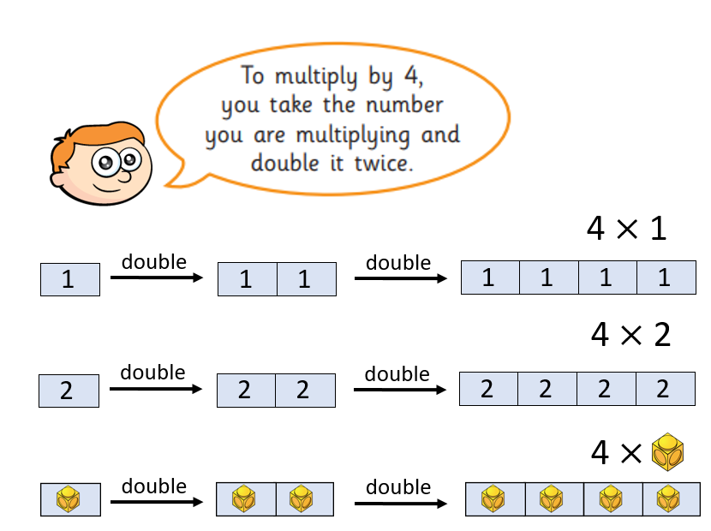

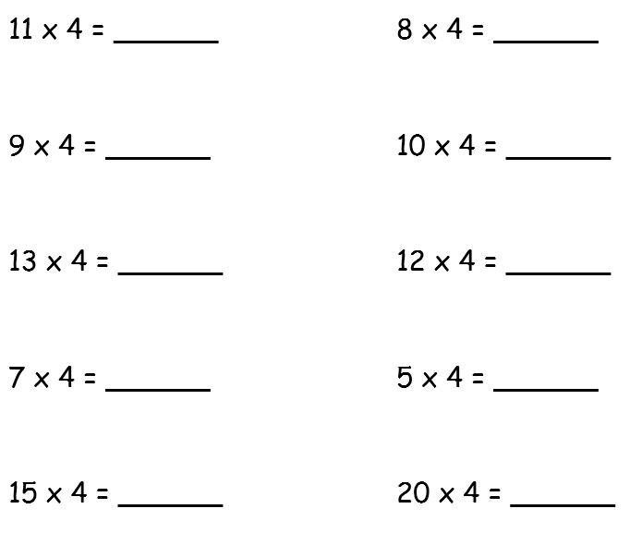

So for the first one double 11 to make 22 then double again to make 44 please

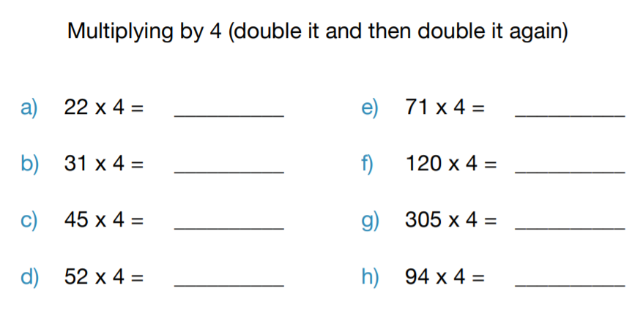

If you’re feeling brave? You can do it!