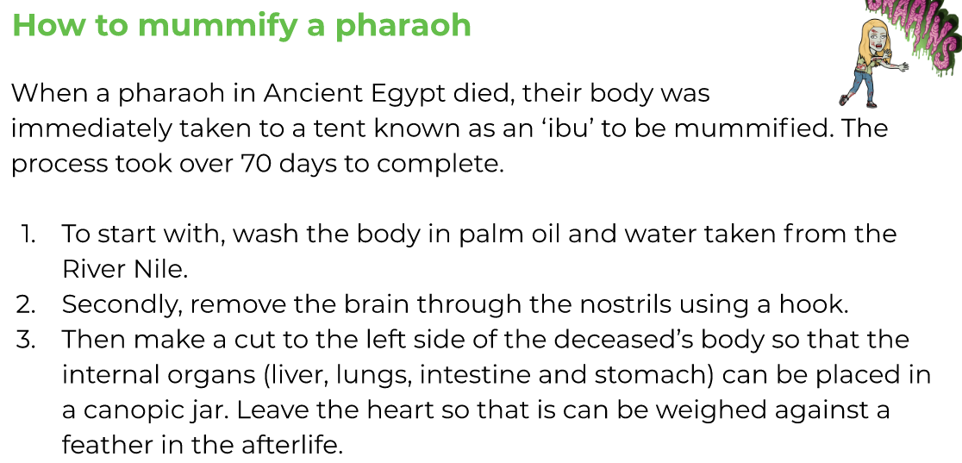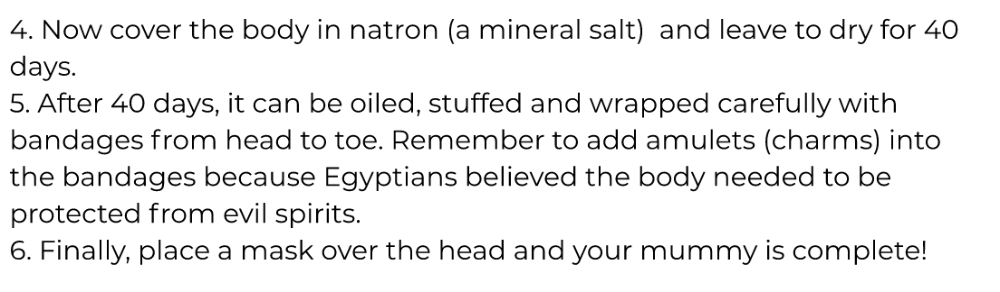

1. First highlight:

Blue -adverbials of time and number

Orange – pronouns

Dark blue – conjunctions

1. Can you underline the imperative verbs?
2. Now try and answer the following questions about the text:
3. Where should you get the water to wash the body?
4. How do you remove the brain?
5. What is natron?
6. Why were amulets added to the bandages?
7. Can you find another word in the text, that means the same as ***dead***?